

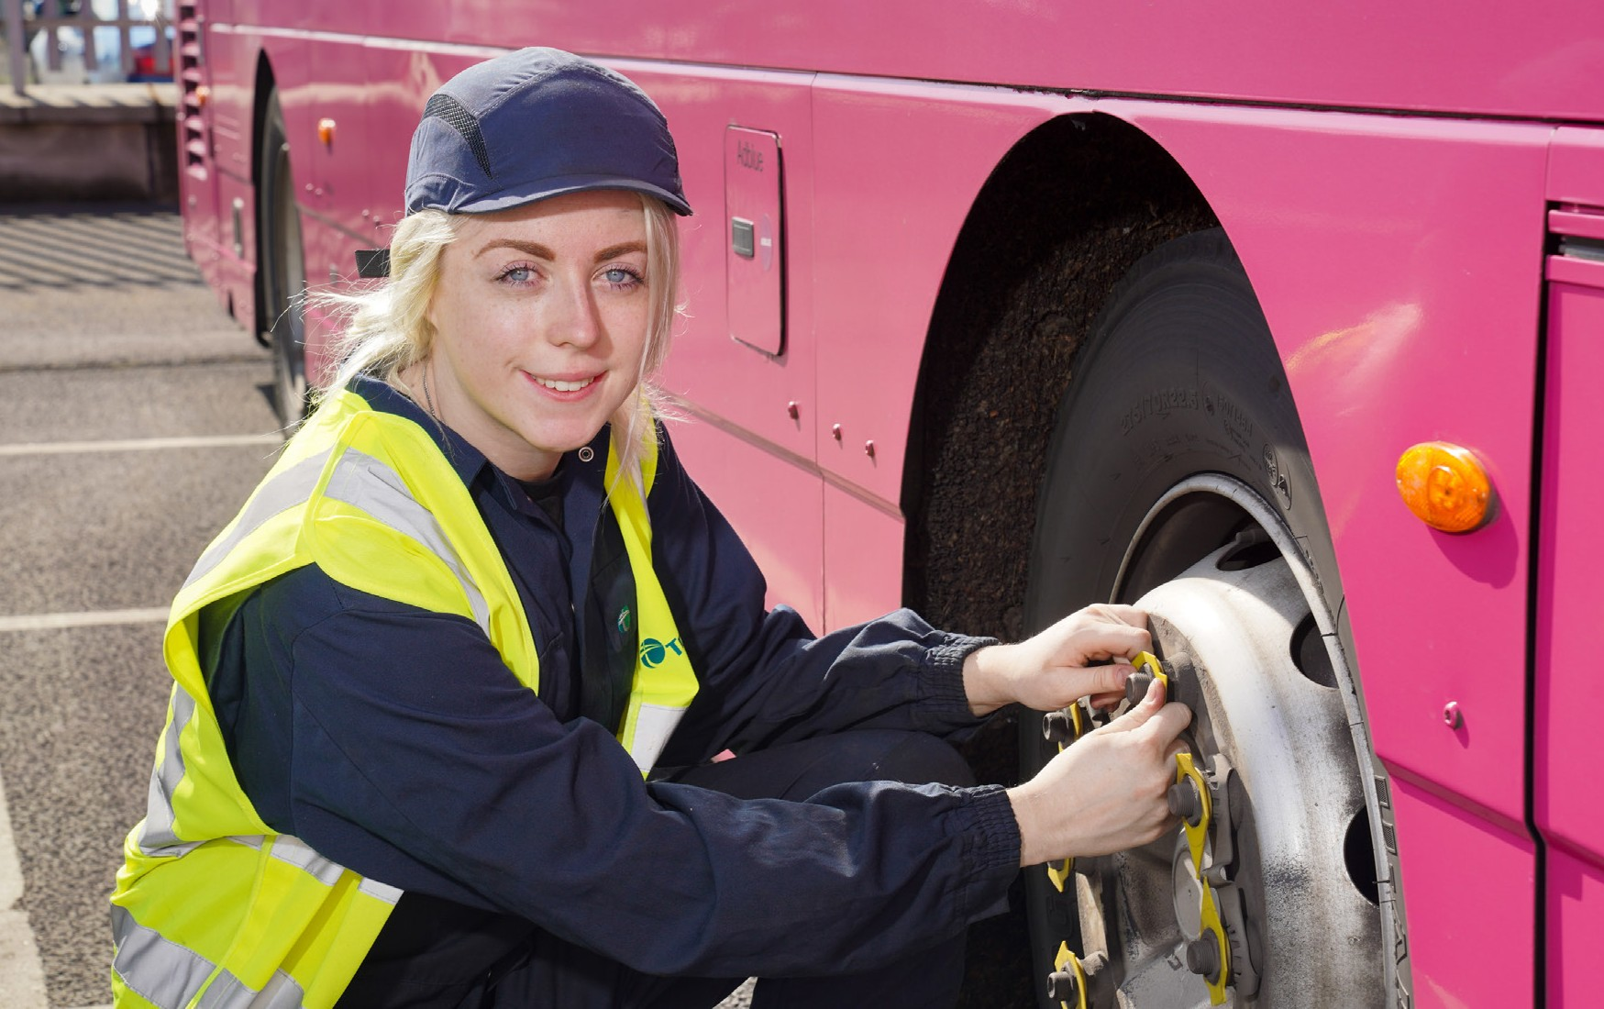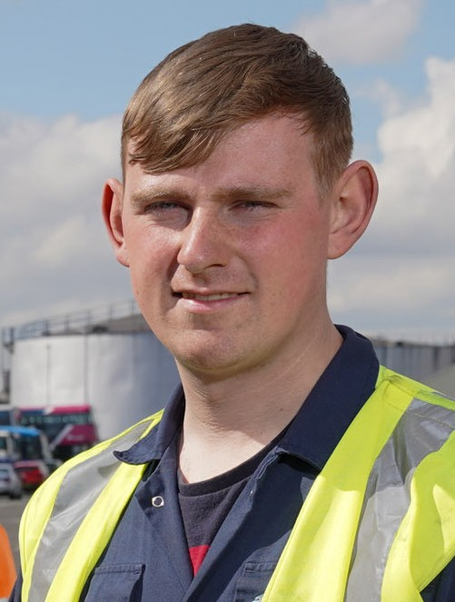

GATEWAY TO YOUR FUTURE

Bus and Rail Engineering Apprenticeships

with Translink 2023



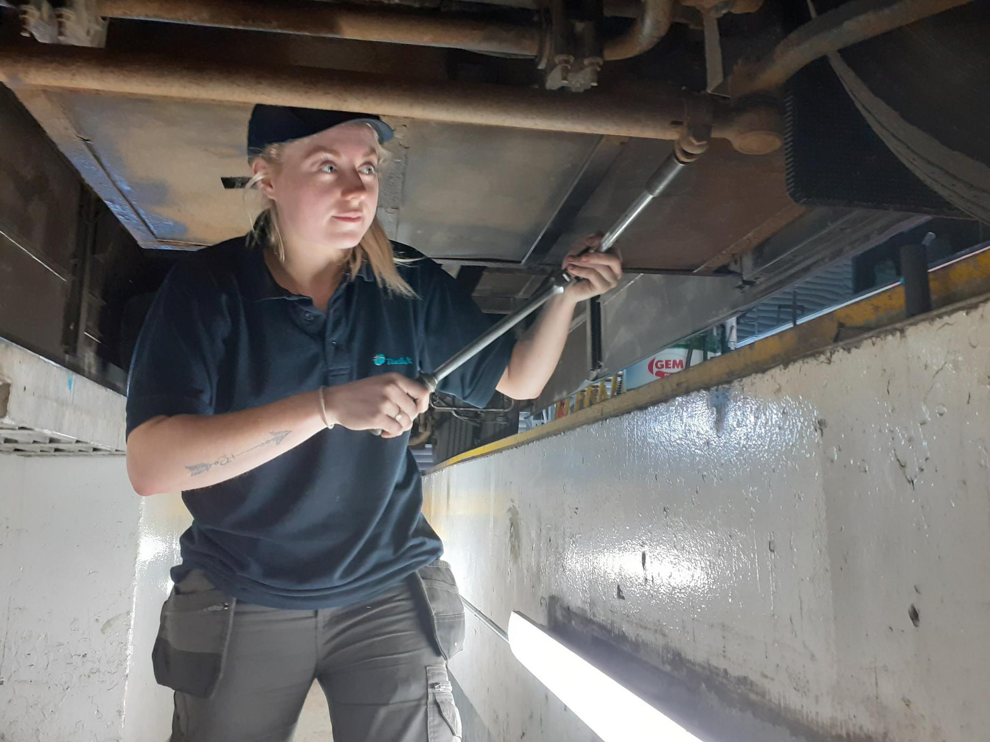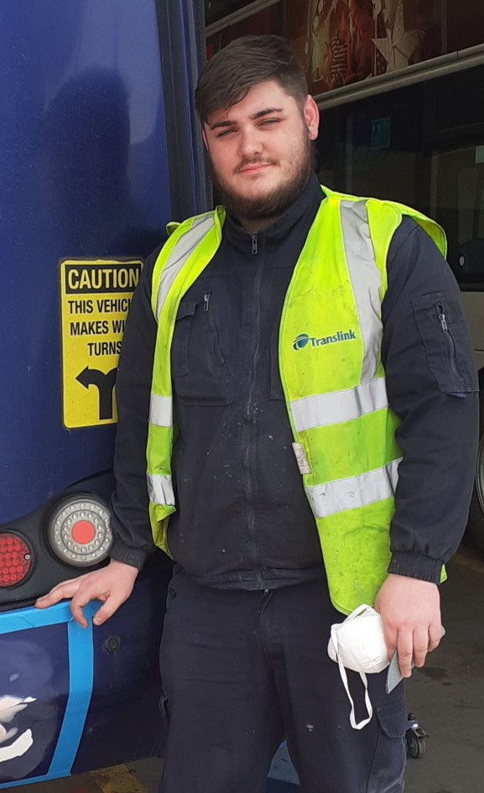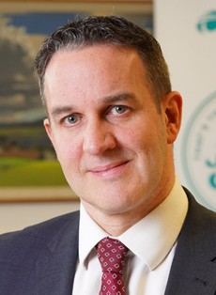

WELCOME TO TRANSLINK

**Foreword**

Thank you for your interest in the Translink Apprenticeship Programme. This is an exciting time to join a dynamic and growing company with significant opportunity to fast track your career within one of Northern Ireland’s largest organisations.

Translink provides award-winning bus, coach and rail services and is recognised as an industry leader who has continued to deliver strong performance despite challenging economic times. At present, we have over 4100 employees and pre- covid were responsible for approximately 84 million customer journeys each year.

Translink’s commitment to zero emission public transport took a step forward with the recent launch of our zero emission bus fleet for Belfast Metro, and we’ve

exciting plans for both Foyle Metro and Ulsterbus. In parallel we’ve been increasing the capacity on our rail network through the delivery of our lengthened six car trains.

This Translink Bus and Rail Engineering Apprenticeship Programme is an excellent opportunity to develop your skills and your career alongside a diverse and experienced team, who will mentor and encourage you along the way. If you like working in a team, are enthusiastic and conscientious then I would encourage you to apply. We will support Apprentices in their development, ensuring they reach their full potential to establish future careers in Engineering.

The future is exciting for Translink and we look forward to you playing your part on that journey.

May I take this opportunity to wish you all the best with your application.

**David Barnett**

General Manager Engineering

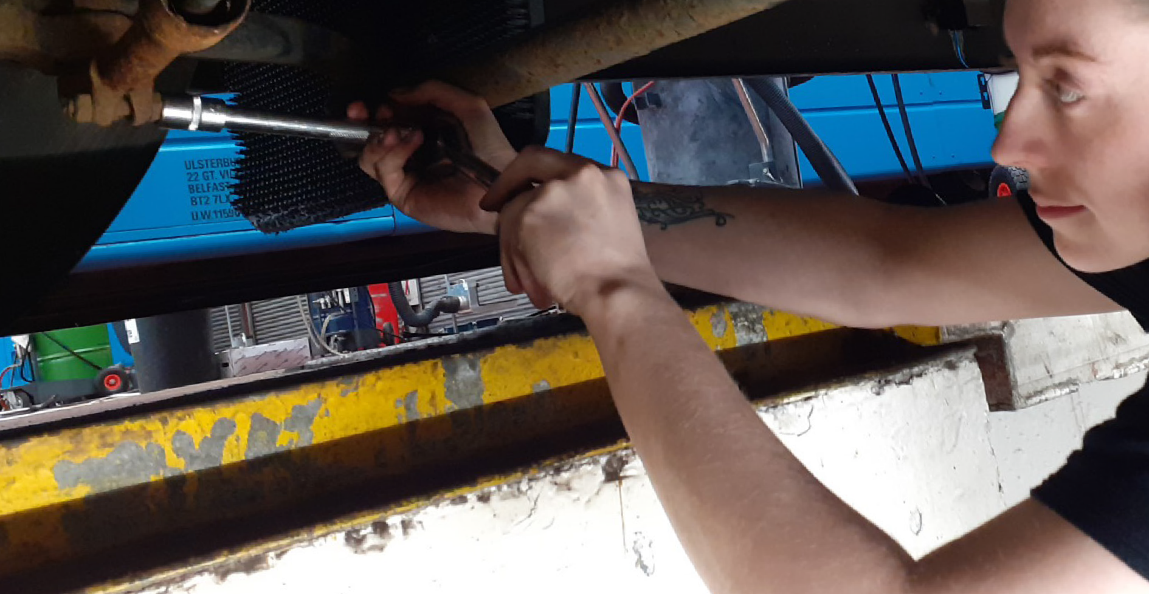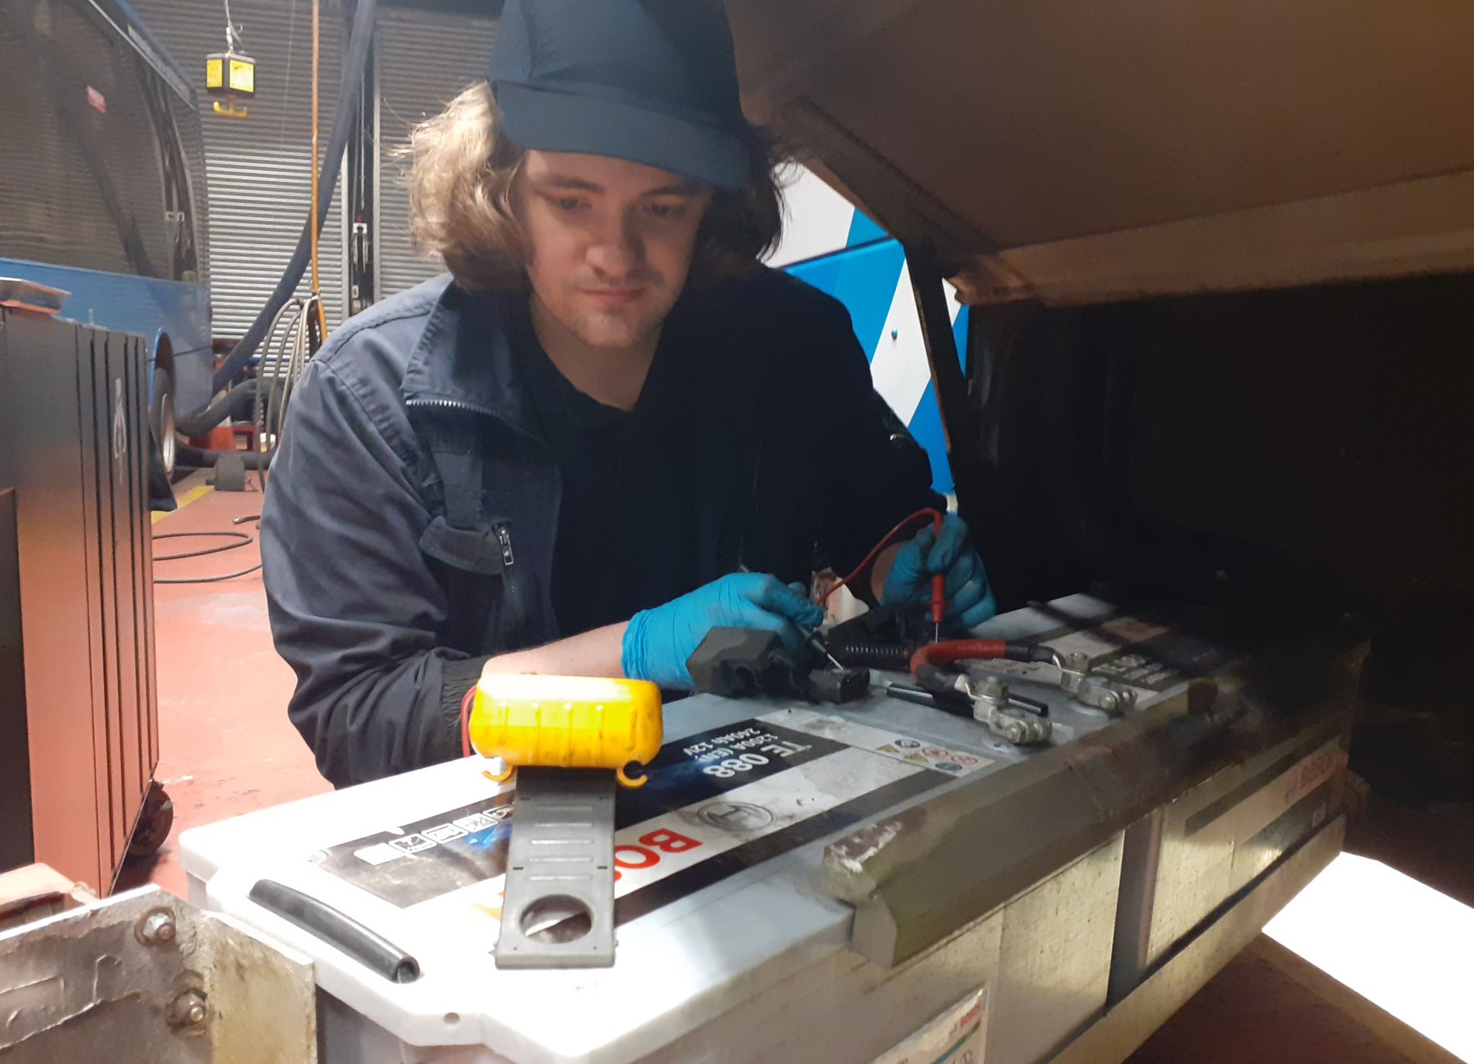

WHO ARE TRANSLINK?

Translink is Northern Ireland’s main public transport provider. We are a public corporation which has a degree of commercial independence, yet are governed in policy terms by the Department for Infrastructure. We provide an essential public service to the people of Northern Ireland which impacts on everyone, supporting economic growth, social inclusion and the welfare of the local communities we serve. This supports the growth and prosperity of Northern Ireland

The Engineering Division plays a major role in ensuring safe, reliable, and well- presented buses and trains are available for service when required. The teams operate from 26 workshops across the province and utilise the latest technology with a focus on continuous improvement.

**‘‘**

We are an award-winning engineering department and have gained many accolades over the years including: The Institute of Road Transport Engineers, the Northern Ireland Apprenticeship Awards and IRTEC Skills Challenge Award where we get the opportunity to compete against other UK bus operators.

Your first choice for travel, today, for tomorrow.

TRANSLINK VISION

As an Engineering Apprentice in Translink we will give you the opportunity to learn and develop your skills and knowledge. In fact, many of our engineering management positions are currently occupied by previous Apprentices which highlights the high standard of recruitment and training received.

If learning about the latest technology on vehicles is what you are interested in, now is a great time to join the engineering team at Translink. In addition to our Glider fleet of hybrid vehicles we have recently launched over 100 zero emission vehicles into our bus fleet in Belfast. These Battery Electric and Fuel Cell Electric Vehicles employ the very latest technology. Translink have ambitious plans which will see this zero emission technology rolled out across our fleet in Northern Ireland – moving us closer to our goal of becoming net carbon neutral by 2040.

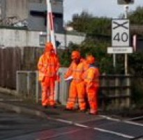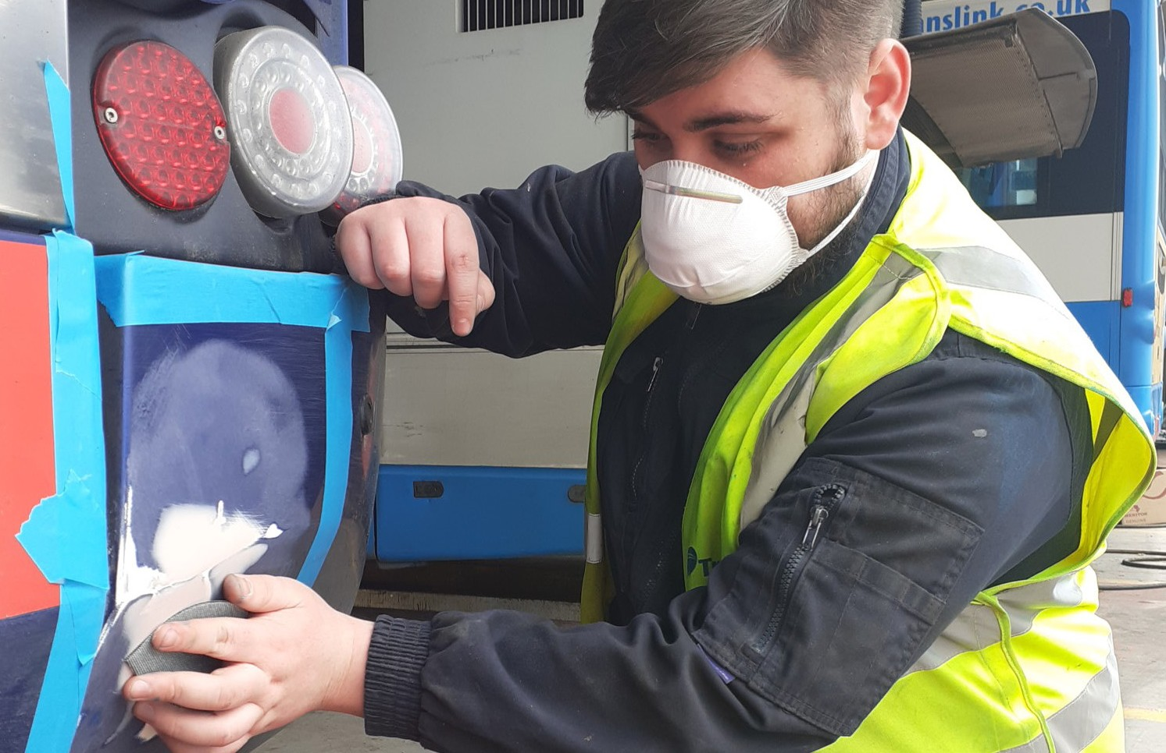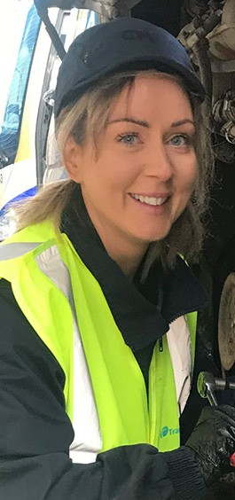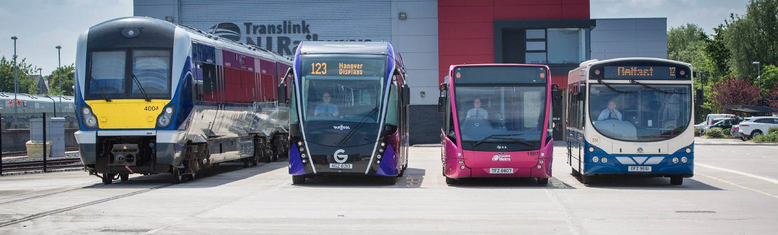

WHY YOU SHOULD APPLY FOR OUR APPRENTICESHIP SCHEME

Practical on-the-job training

Gain experience and a professionally accredited qualification at the same time at no

monetary cost to you!

Competitive salary

TRANSLINK

VISION, MISSION AND VALUES

Translink’s mission is to work innovatively, taking a collaborative approach with all appropriate stakeholders to deliver a transformation in public transport, providing integrated services which connect people, enhance the economy and improve the environment, enabling a thriving Northern Ireland.

Translink is passionate about providing excellent public transport and this is endorsed by their guiding Values;

**Safety, People, Innovation, Responsibility, Integrity and Teamwork. This is the Translink ‘SPIRIT’.**

Career progression and personal development

Minimum of 26 days annual leave + set public holidays

(pro rata)

Free travel (subject to eligibility) on Translink services

Attractive NILGOSC Pension Scheme

Opportunity to join Employee Benefits Scheme offering you discounts from local retailers and service providers including restaurants, gym membership, hotels, cinemas etc.

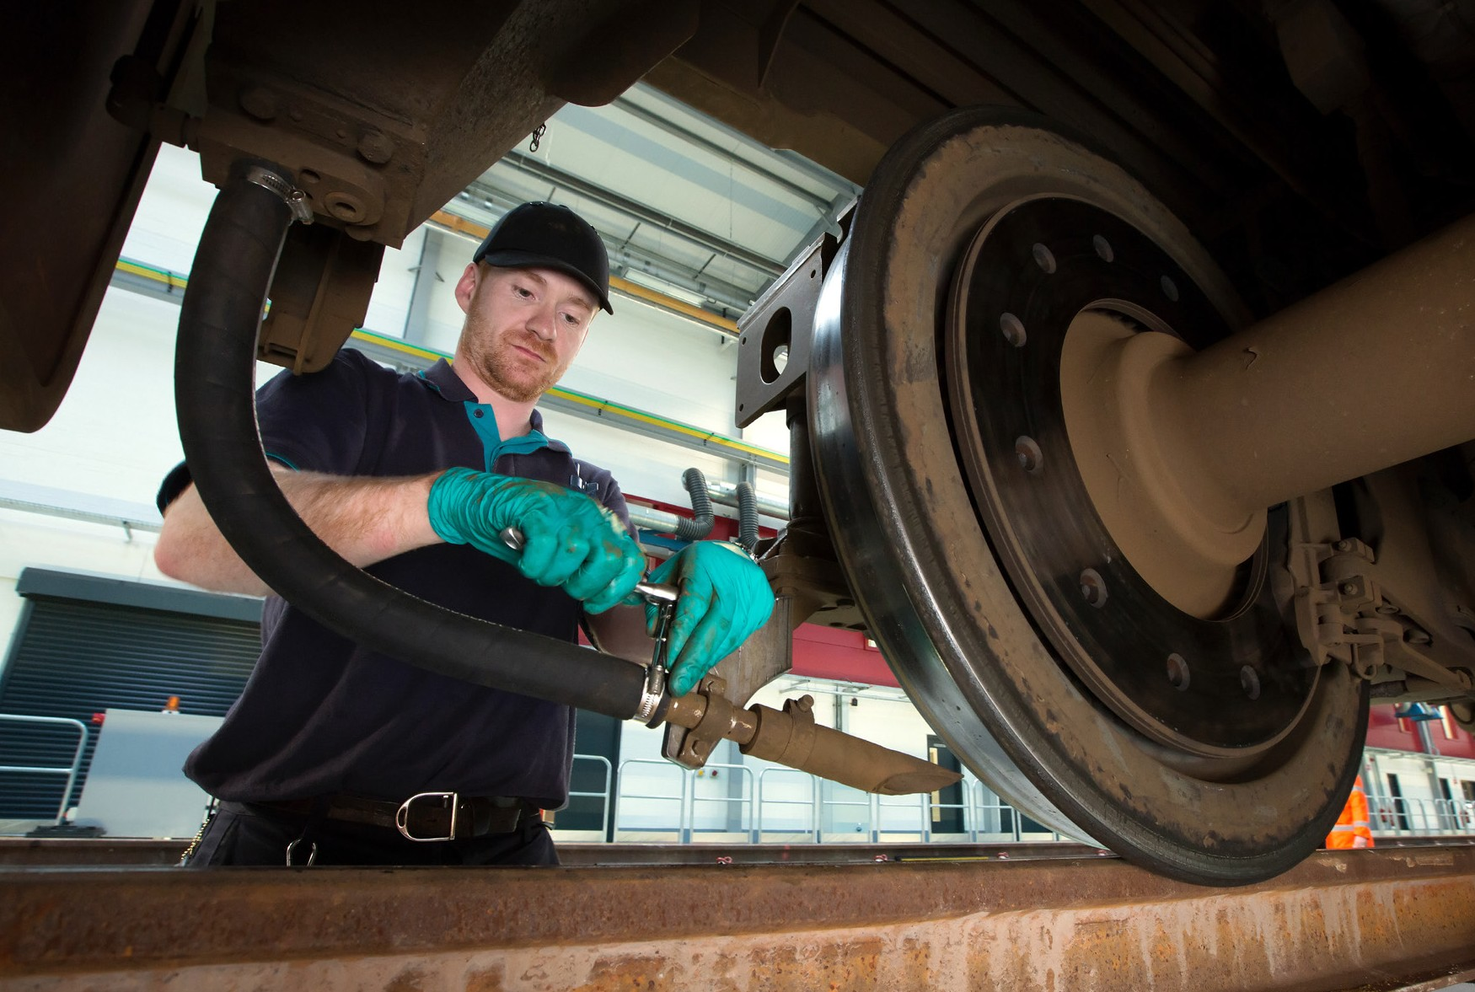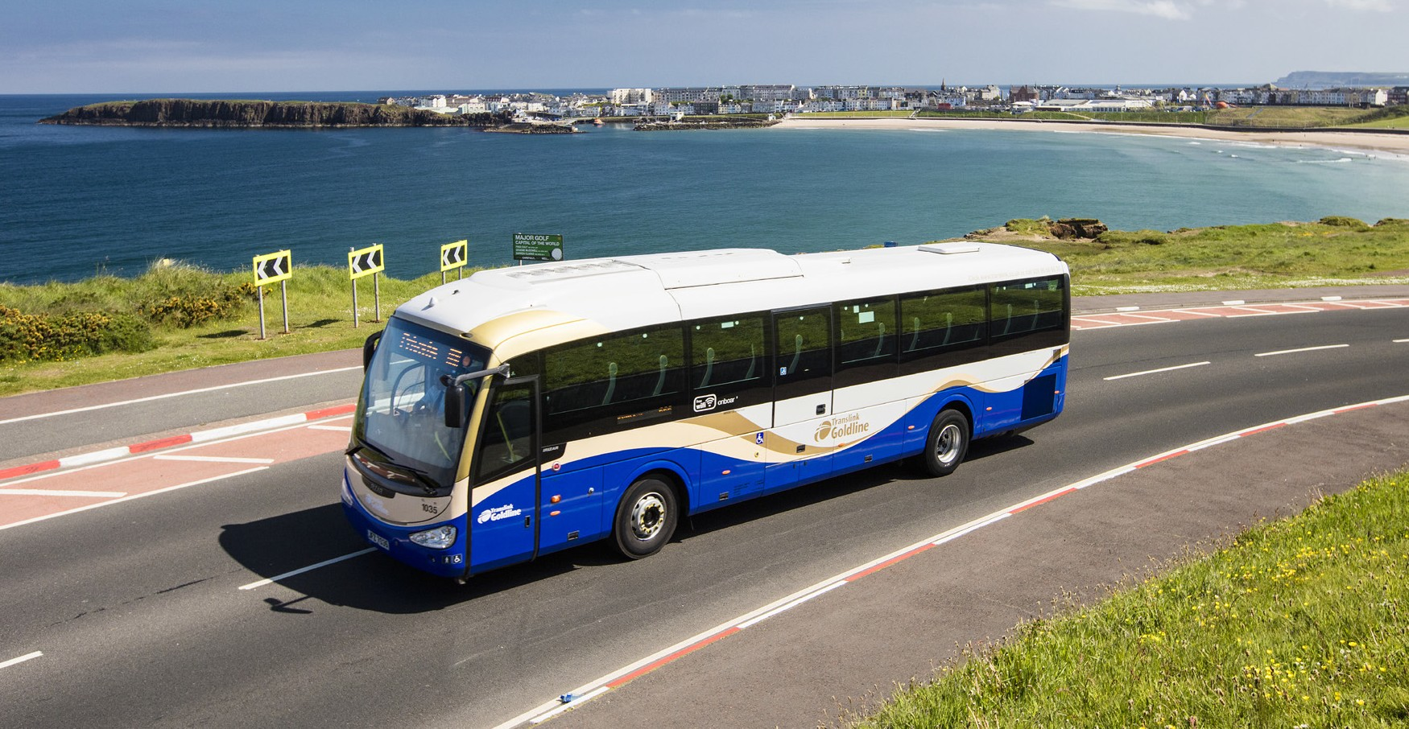

**What is an Apprenticeship?**

An Apprenticeship is a real job offering hands on experience, comprehensive training and a technical qualification all whilst earning a salary. The Translink Apprenticeship Programme will give you the skills, knowledge and behaviours to become an Engineer.

For these opportunities in Bus and Rail Engineering anyone aged 16 years or over can apply. All our apprentices are fully employed by Translink from the first day of their apprenticeship with a contract of employment, paid holidays and many other competitive benefits. As an apprentice you will be working with experienced staff and learning from colleagues across all levels of the business.

Completing an apprenticeship with Translink will equip you with skills for life as well as enabling you to secure permanent employment and gain a professional level 3 NVQ qualification.

This Apprenticeship involves a combination of working and learning on site at a Translink workshop for 4 days a week whilst attending college on one day to

complete a formal NVQ Qualification. You will benefit from the knowledge of skilled professionals who will support and mentor you as you learn.

TRANSLINK ENGINEERING APPRENTICESHIPS 2023

Translink, operating as Ulsterbus, Metro, Northern Ireland Railways and NITHCo, operates 1410 buses, coaches and Gliders, alongside 47 trains, providing the Northern Ireland public with comprehensive stage carriage, express and school transport services. This extensive provision requires modern and varied engineering facilities which are located throughout the province.

In order to maintain and develop the highest standards of engineering, we have identified opportunities for structured 4-year Apprenticeships which will commence in September 2023.

**‘‘**

Your first choice for travel, today, for tomorrow.

TRANSLINK VISION

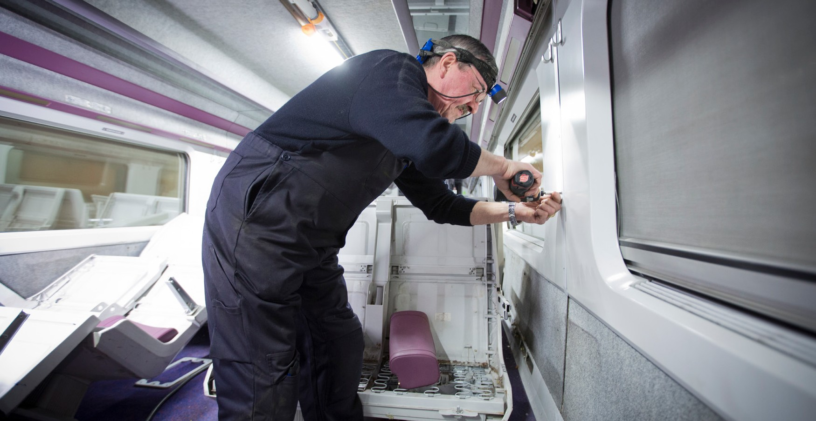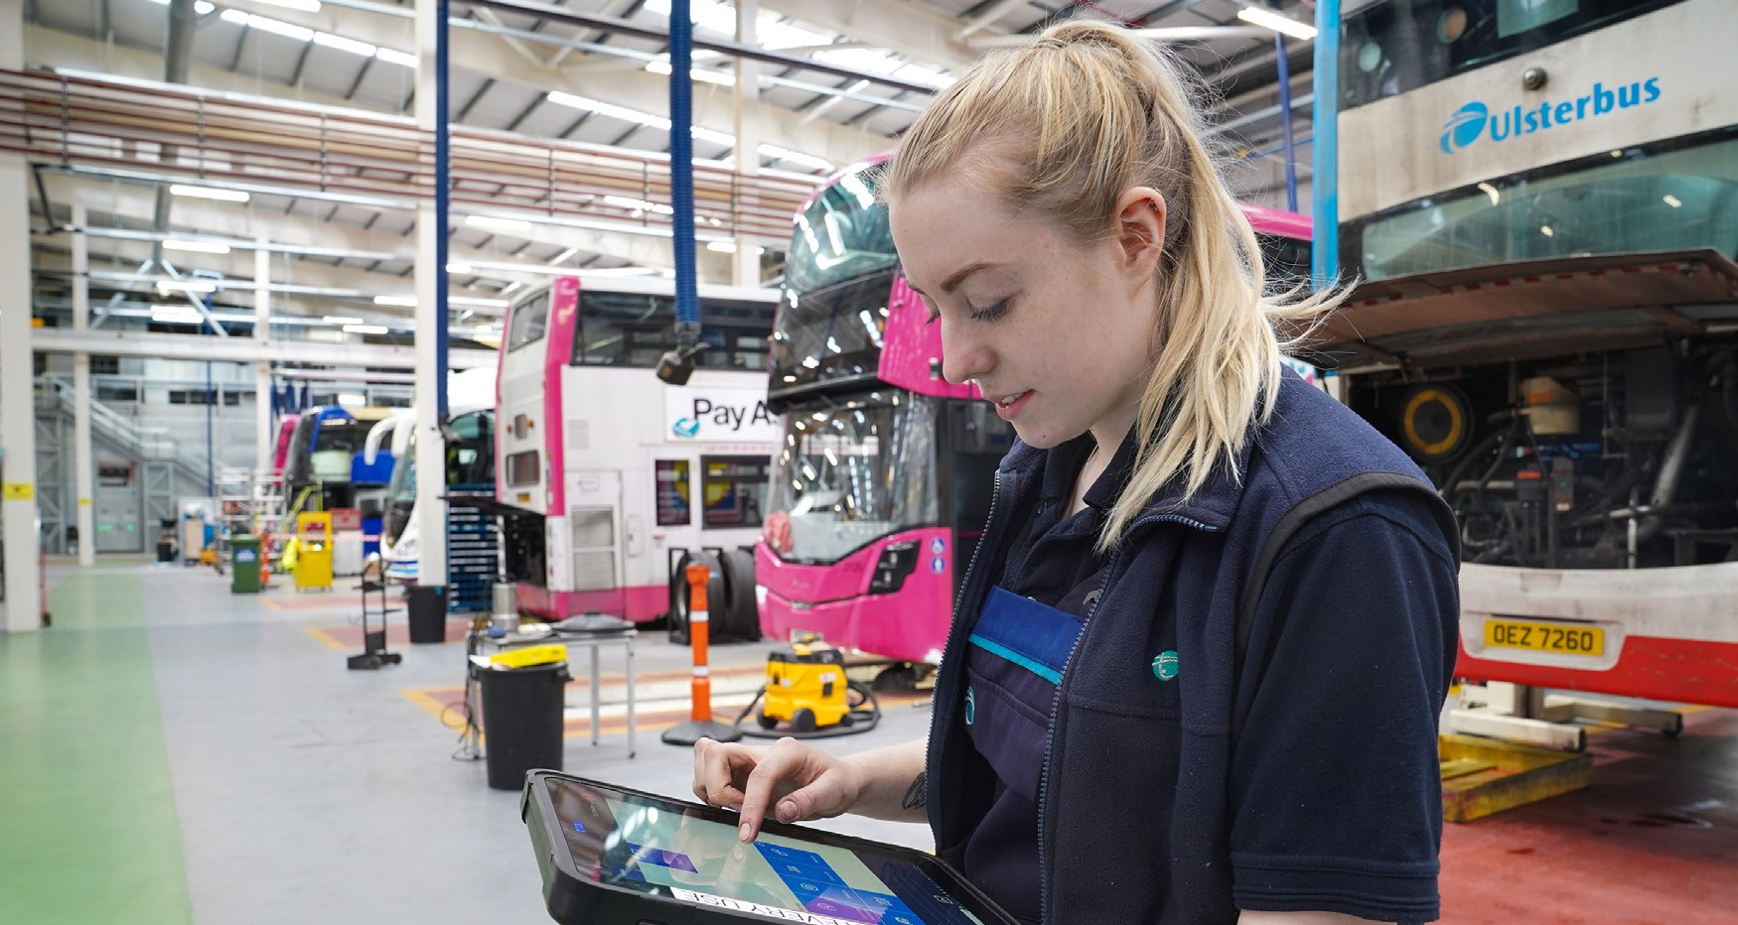

ENGINEERING APPRENTICESHIP ROUTES

We currently have opportunities available for Bus and Rail Engineering Apprenticeships across the following trades -

**Technical Trades**

A Technical Trades Apprenticeship is four years in duration. With today’s modern vehicle it is recognised that training in a combination of mechanical and electrical systems is essential. To ensure that adequate training on both systems is provided we take the apprentice through four NVQs i.e. Mechanical and Electrical at

level 2, Mechanical and Electrical at level 3. This approach is designed to equip our apprentices with the knowhow and skills required for the future and to

instil confidence in the Apprentice ensuring they are competent in both trades. Apprentices attend college one day per week with the remaining four days spent at a Translink workshop where the college training is put into practice.

**Rail Engineering Technician Traction & Rolling Stock**

As a Railway Technician Apprentice, you will focus on gaining an understanding of vehicle design, construction, maintenance and operations. You will develop a working knowledge of the traction and rolling stock systems, sub systems and

components which include mechanical, electrical, process control and fluid power equipment.

**Body Trades**

A Body Trades Apprenticeship is four years in duration and combines the skills of three core trades i.e. Sheet Metal, Body Building and Painting. Body Trades Apprentices will attend a further education college on a day release basis for

three years to undertake a Coach and Bus Body qualification. Upon completion, Apprentices will be qualified to NVQ Level 3 including a Technical Certificate.

When not at college Apprentices work in a Translink workshop.

Apprentices will attend a local college one day per week in order to achieve an NVQ level 3 in Engineering Maintenance and a BTEC level 3 Diploma in Engineering.

On completion of this qualification your systems knowledge will include safety systems, traction, wheel sets, brakes, train protection, air conditioning and ventilation, customer information, doors, vehicle trim and fittings. You will be able to find, diagnose and correct faults in a wide range of systems including electrical circuits and maintain and renew a range of types of traction and rolling stock.

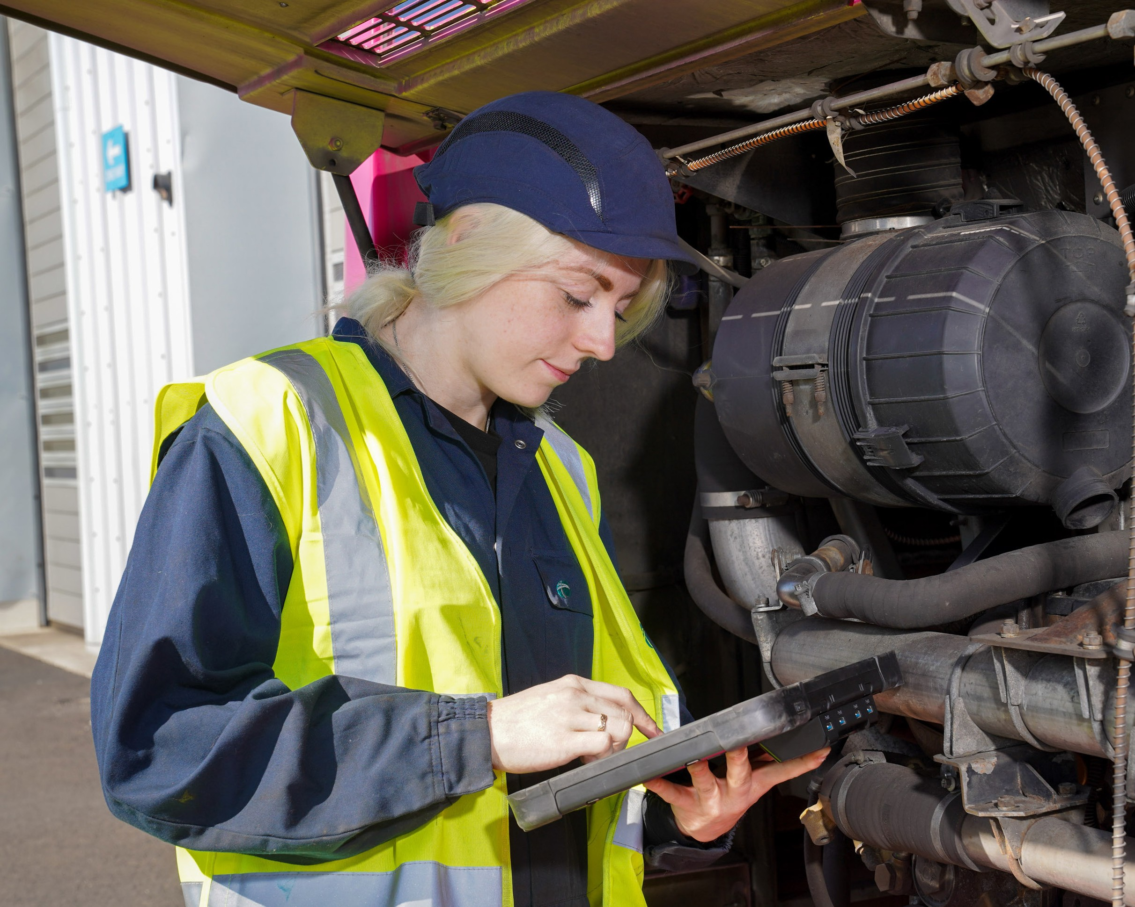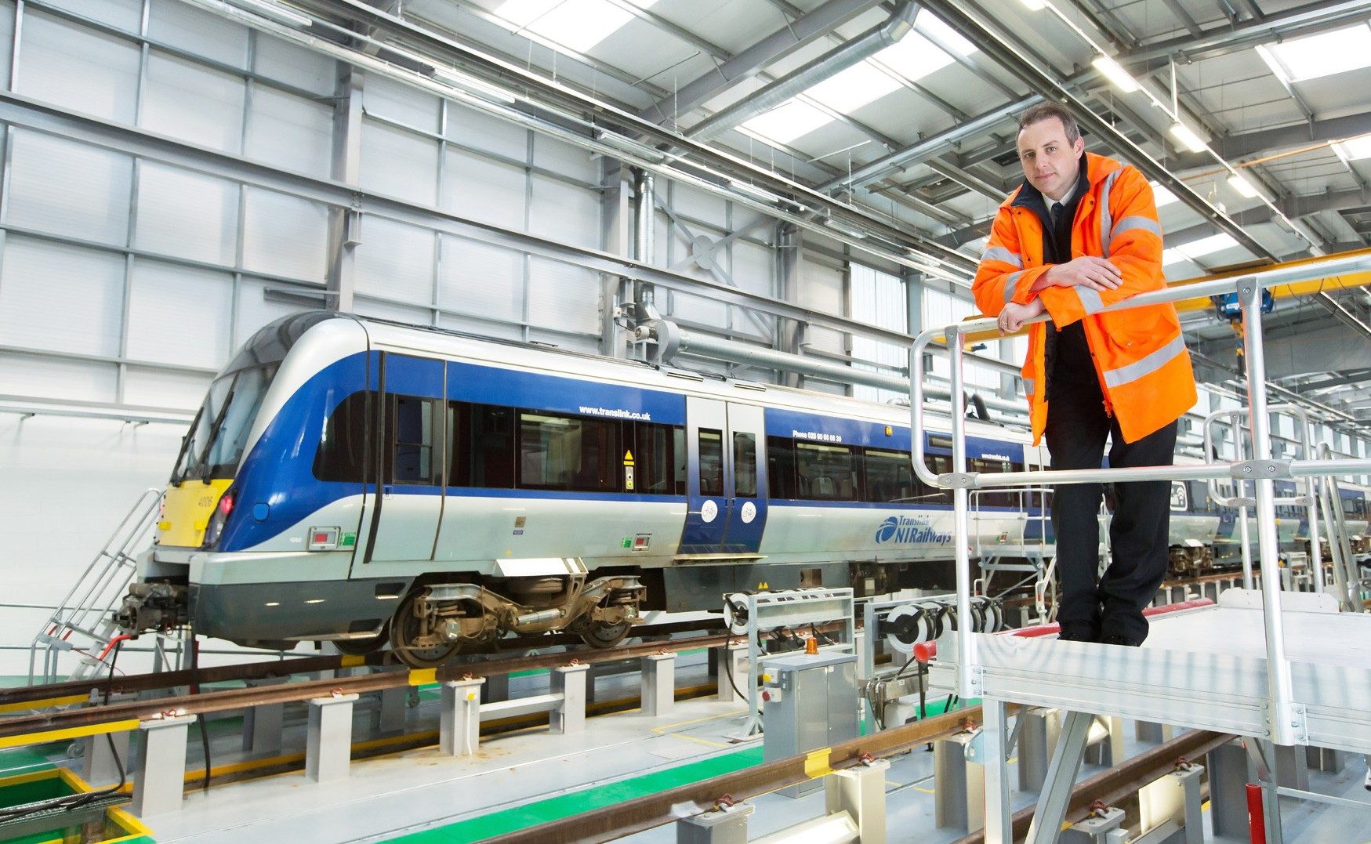

BENEFITS

•

•

•

•

•

•

•

A competitive salary

Attractive NILGOSC pension including employer contribution Minimum of 26 days annual leave plus statutory holidays Diversity and inclusion networks and initiatives

Monthly wellbeing initiatives

Employee benefits scheme offering many discounts

Access to Cycle to Work scheme enabling you to purchase a new bike and safety equipment up to the value of £2,000 for up to 30% less than the original cost through salary sacrifice

Confidential counselling service

Opportunity to get involved in charity fundraising and social value initiatives Volunteering opportunities

•

•

•

LOCATIONS

**Locations of Engineering Apprenticeship Opportunities**

The Bus Engineering Apprenticeships will be based at depots in Belfast, Derry/Londonderry, Enniskillen, Craigavon and Newry.

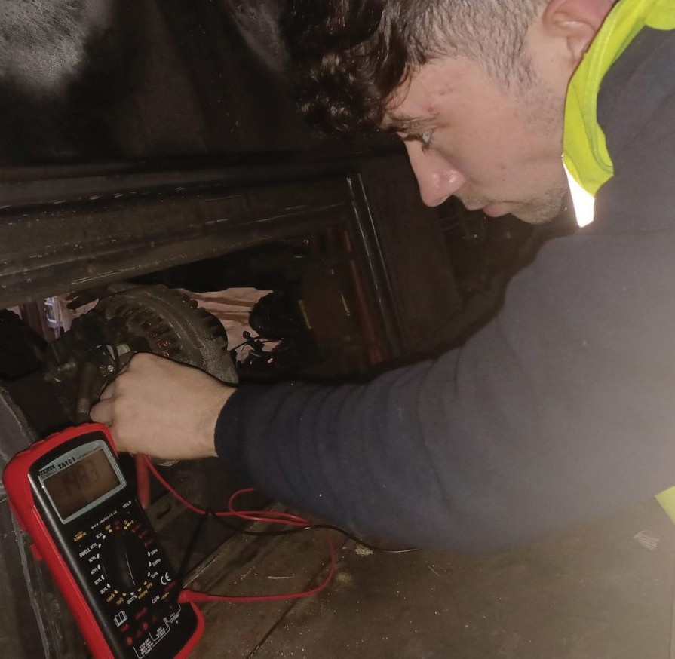

**Are there alternative routes to the job?**

There are some other routes into the job; you could first get a degree and then do an apprenticeship. You could also do an apprenticeship with another company and then apply for a full-time position once out of your time.

MEET AN APPRENTICE

**What does a typical day entail?**

I get to work at 7am and clock in and after that every day is different as I work in a running repair shed. We carry out safety checks on buses every day and we also

must deal with any problems that come in off the road. Sometimes we also must go out to breakdowns as well.

**Aaron Reid**

YEAR 2 APPRENTICE

Technical Trades Falls Depot

**What are the best and most challenging aspects of the job?**

The best and most challenging aspect of the job is the same thing, the fact that every single day you are learning new things. New problems you have never seen before, the buses are always being upgraded.

**Why is what you do important?**

Public transport is a crucial part of any country’s infrastructure, it is important for helping the environment, getting people to work, and making parts of the country more accessible. Keeping the buses on the road in good condition is vital for public transport’s reputation.

Give a brief outline of your career to date?

I left school after my A-levels not knowing what I wanted to do, I just knew that I had an interest in engineering, solving problems and fixing things. I decided to hold out on university for a year and do an HNC in electrical and electronic engineering in Belfast met. One of my modules in this course was mechatronics and I loved it, I decided to apply for this course in Jordanstown the next year. I had done two years of mechatronic engineering in Jordanstown as well as working as a concreter at the weekends. I really did not enjoy the university lifestyle and I just wanted to get into the working world. I left university and applied to the translink apprenticeship scheme. I am now in my second year of the apprenticeship.

**What advice would you give anyone looking to follow a similar career path?** The most important piece of advice I would give someone looking to follow a similar career path is to be interested and not waste any time applying.

**What is the one piece of advice you would give yourself on your first day?**

Be curious every single day, there is so much to learn, and it is important to always stay curious and be hands on.

Is this what you always wanted to do?

No, this is not what I always wanted to do but I always had an interest in cars and engines growing up. I had just never considered it as a full-time career. Looking back now it would have made sense for me to make this move years ago and I wish I had.

**‘‘**

...every single day you are

**Were there any particular qualifications or experience needed?**

Besides some good GCSE’S and A-levels there were no qualifications needed, however I believe that my HNC in electrical and electronic engineering really helped me get into the apprenticeship.

learning new things

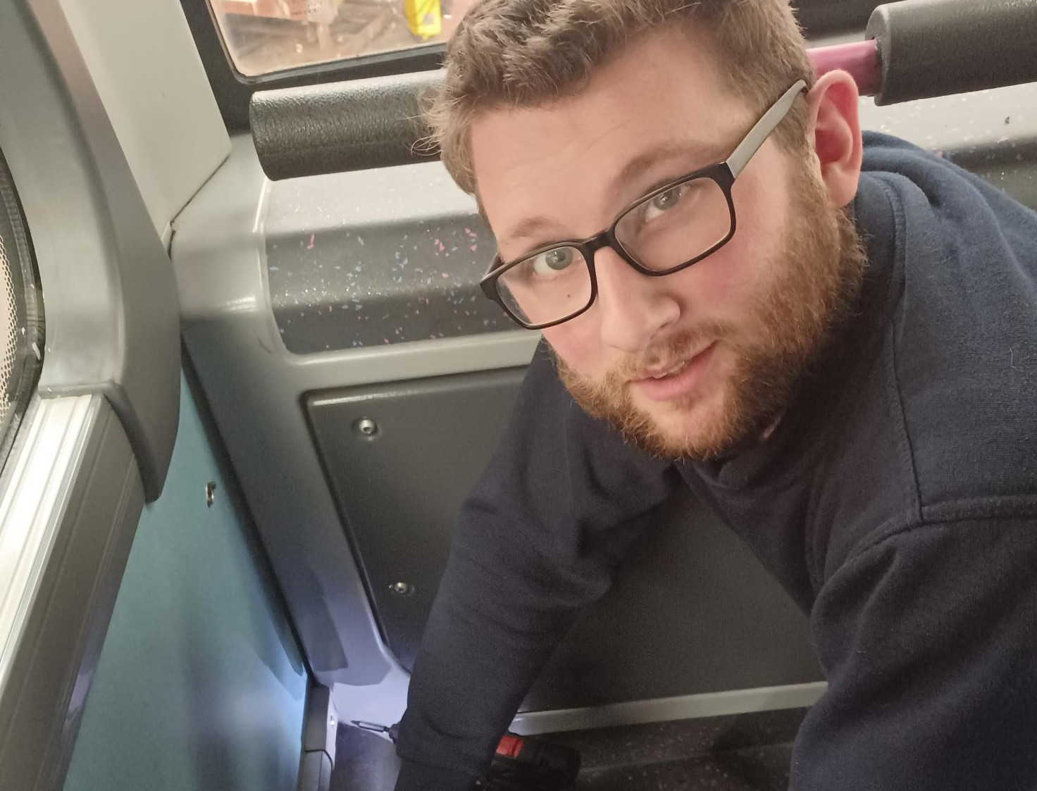

**Are there alternative routes to the job?**

You can complete an apprenticeship elsewhere and then apply for a position as a time served trades person.

MEET AN APPRENTICE

**What does a typical day entail?**

No two days will be exactly the same, it really depends on the repairs required. I could be removing and replacing seats, repairing or replacing body panels, fixing doors or locks, checking the security of windows, floor repairs, bus inspections etc.

**What are the best and most challenging aspects of the job?**

When a vehicle comes in with damage, the challenge of repairing the damage and turning the vehicle back out as good as new gives me a great sense of job satisfaction.

**David Anderson**

YEAR 4 APPRENTICE

Body Trades Falls Depot

**Why is what you do important?**

The presentation and how the buses are turned out is really important as it reflects on the company image and will encourage people to want to travel on our vehicles.

**What advice would you give anyone looking to follow a similar career path?** Apart from great training, conditions and free travel an apprenticeship means you are employed from day one. You are also earning while learning.

Give a brief outline of your career to date?

Before coming to Translink I did an HNC in Engineering.

**What is the one piece of advice you would give yourself on your first day?**

Don’t get overwhelmed. Remember it takes time to settle in. Remind myself what a great opportunity this is, give it my best.

Is this what you always wanted to do?

I always had an interest in vehicle body repair but I hadn’t really considered buses until this job opportunity came up.

**What is the key to a successful job search**

If you are interested in joining Translink, follow them on all aspects of social media, turn on all job alerts and keep up to date with new roles advertised on [www.translink.co.uk/apprenticeships](http://www.translink.co.uk/apprenticeships)

**Were there any particular qualifications or experience needed?**

It isn’t necessary to have experience, but it helps to demonstrate an interest in the trade. You need five GCSEs including Maths and English.

**‘‘**

...a great sense of job satisfaction



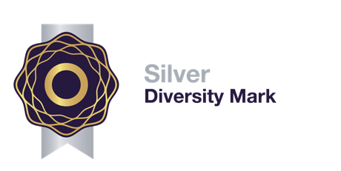

GATEWAY TO YOUR FUTURE

Engineering Apprenticeships with Translink 2023

APPRENTICE PROFILE

**Minimum Criteria**

•

•

Aged 16 years or over

Minimum of 5 GCSE’s at grade C or above (or equivalent qualification) including Maths and English

Experience of using Microsoft Office packages

Able to demonstrate examples of a practical hands-on approach Team player with a positive attitude

Committed, self-motivated and willing to respond to the needs of the Apprenticeship scheme

Excellent communication skills

Understand how to provide an excellent customer experience

•

•

•

•

•

•

**Recruitment Process**

1.

2.

3.

4.

Online application form - [www.translink.co.uk/apprenticeships](http://www.translink.co.uk/apprenticeships) Aptitude testing

Interview

Pre-employment references, medical and qualification checks (if successful)

EQUAL OPPORTUNITY POLICY

*Translink values its employees and is committed to building a diverse and inclusive workplace that attracts, retains and develops the best talent. We are an equal opportunities employer, in this instance applications from women would be particularly welcome.*