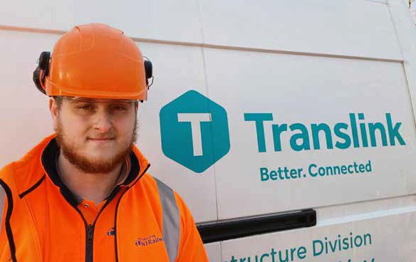

GATEWAY TO YOUR FUTURE

Infrastructure and Projects Apprenticeships

with Translink 2023



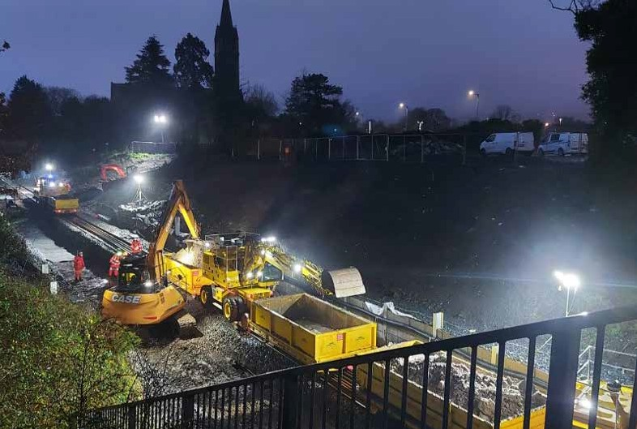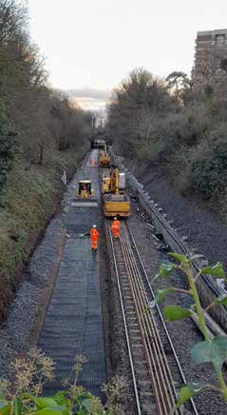

## WELCOME TO TRANSLINK

**Foreword**

Translink are delighted to offer opportunities to join our Infrastructure and Projects division as an Apprentice in 2023. We are recruiting Apprentices across Infrastructure and Projects areas to include Civil Engineering/Structural

Engineering, Railway Engineering (Track) and Telecoms and Electrical Engineering (Signalling and Telecoms). Our Apprenticeship programme will provide you with the skills, knowledge and qualifications you need to develop a career within infrastructure engineering.

Our Apprentices will have the opportunity to work for an organisation who are playing a key role in the transformation of transport in Northern Ireland, connecting people and communities. Better Connected transportation will deliver positive change on Climate Action, Customer Focus, Continuous Improvement and Connecting Communities.

This Translink Infrastructure and Projects Apprenticeship Programme is an excellent opportunity to explore your skills and develop your career alongside a diverse and experienced team, who will mentor and encourage you along the way. If you like working in a team, are enthusiastic and conscientious then I would encourage you to apply. Apprentices develop to their full potential and progress into higher levels and work in partnership with local colleges, universities and professional bodies to establish future careers in the built environment.

I wish you every success with your application.



**John Glass**

Director of Infrastructure and Projects

## WHO ARE TRANSLINK?

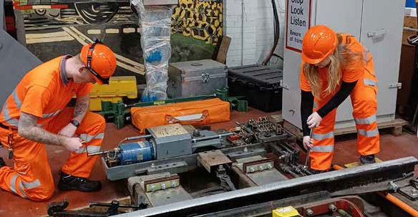

**‘‘**

Your first choice for travel, today, for tomorrow.

TRANSLINK VISION

Translink provide bus and rail services across Northern Ireland, over extensive infrastructure and estates which is managed by a team of specialised Engineers and Project Delivery Professionals. In order to maintain and develop the highest standards of infrastructure we have identified opportunities for Translink Infrastructure and Projects Apprenticeships for 2023.

Apprentices will benefit from working on a wide range of infrastructure assets that exist throughout the Translink network This includes over 300 miles of railway, 400 bridges, signalling and telecoms, level crossings as well as all the halts, stations, park and ride sites and integrated transport hubs. It is an ever-changing built environment with key projects evolving as part of the transformation of public transport across Northern Ireland.

The Translink Infrastructure and Projects division manages, monitors, maintains and reviews all infrastructure and projects that support NI Railways, Ulsterbus, Metro and Glider services. Translink Infrastructure and Projects teams are involved from the inception planning stage right through to construction and completion of projects and play a vital role in the successful delivery of key developments,

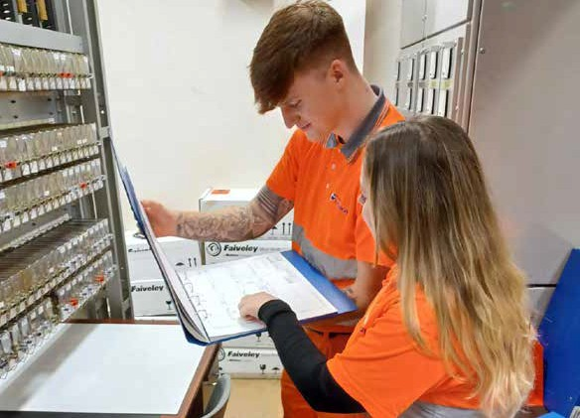

including the multi award-winning North-West Multimodal Transport Hub. Weavers Cross and the new world class Belfast Grand Central Station are key infrastructure regeneration projects, delivering both spatial and social regeneration, as well

as encouraging and enabling a modal shift away from private cars as a primary means of travel.

It is an exciting time to join Translink’s Infrastructure and Projects division and a unique opportunity to develop skills as an Apprentice.

## WHY YOU SHOULD APPLY FOR OUR APPRENTICESHIP SCHEME



Practical on-the-job training

Gain experience and a professionally accredited qualification at the same time at no

monetary cost to you!

Competitive salary



Career progression and personal development

TRANSLINK

VISION, MISSION AND VALUES

Translink’s mission is to work innovatively, taking a collaborative approach with all appropriate stakeholders to deliver a transformation in public transport, providing integrated services which connect people, enhance the economy and improve the environment, enabling a thriving Northern Ireland.

Translink is passionate about providing excellent public transport and this is endorsed by their guiding Values;

**Safety, People, Innovation, Responsibility, Integrity and Teamwork. This is the Translink ‘SPIRIT’.**

Minimum of 25 days annual leave + set public holidays

(pro rata)

Free travel (subject to eligibility) on Translink services



Attractive NILGOSC Pension Scheme

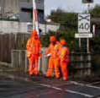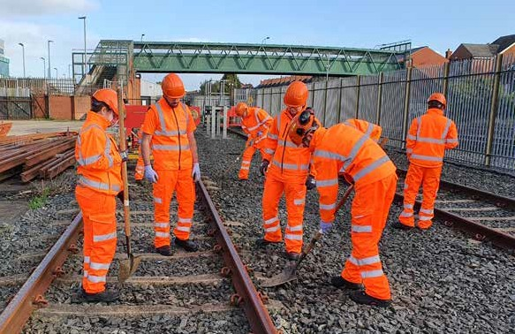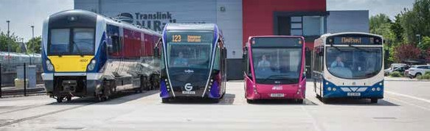

Opportunity to join Employee Benefits Scheme offering you discounts from local retailers and service providers including restaurants, gym membership, hotels, cinemas etc.

## WHAT IS AN

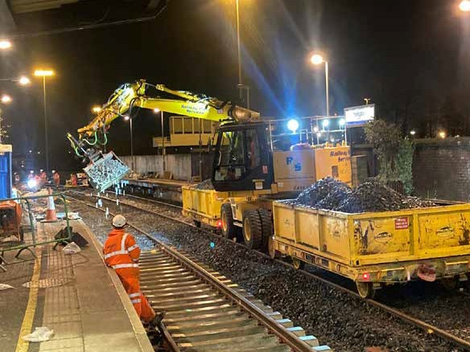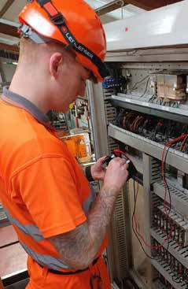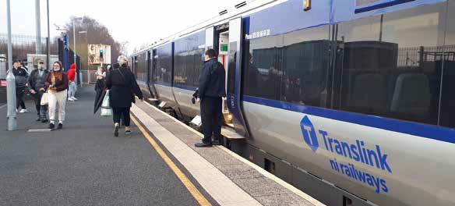

INFRASTRUCTURE AND PROJECTS APPRENTICESHIP?

Infrastructure and Projects Apprenticeships are real jobs offering hands on experience, comprehensive training and a recognised qualification in a range of different disciplines all whilst earning a salary. As an Apprentice you will be employed by Translink and you will have the opportunity to gain qualifications in

Civil Engineering/Structural Engineering, Rail Track Engineering and Telecoms and Electrical Engineering (Signalling and Telecoms).

Apprentices will work towards Diplomas and Degrees as well as additional options for professional development. Throughout your training you will benefit from being mentored by specialised staff who will provide guidance and support to further develop you into Higher Level Apprenticeships (HLA’s – level 5, 6 and 7 programmes) and career progression.

These Apprenticeships are open for applications from anyone aged 18 years old and over. The programme involves a combination of working in an office, depot or other infrastructure sites for up to 4 days a week, with at least one day a week spent at a local regional college or university working towards your qualification.

Given the safety critical nature of railway infrastructure it will be necessary to meet Personal Track Safety competence before working on or near the railway. Full training will be provided, offering practical experience as well as additional safety qualifications as part of the Apprenticeship.

## INFRASTRUCTURE AND PROJECTS APPRENTICESHIP ROUTES

#### We currently have 21 Infrastructure and Project Apprenticeships available across the following disciplines:

**Civil/Structural Engineering**

The Railway Civil Engineering Apprenticeship is the first step towards becoming a professionally qualified Civil/Structural Engineer. Apprentices will commence a 2 year programme of combined work and study towards gaining a BTEC Level 3 Diploma

in Construction and the Built Environment (Civil Engineering) or Natural and Built Environment Civil and Structural Engineering. Higher level qualifications are also possible in partnership with a local college or university, as well as a professional qualification as an Engineering Technician member of the Institution of Civil Engineers (EngTech MICE).

Work at Level 3 will focus mainly on assisting experienced Engineers and Managers with Civil, Structural and Track Engineering projects across the railway network. You will be based in Belfast although may be required to travel throughout Northern Ireland as the role is a mix of office and site-based activities, providing a varied range of experience to support Apprentices’ academic learning. Apprentices will get the opportunity to support both the Capital and Maintenance programmes, working with in-house Engineers on the examination, repair and construction of assets, including bridges, tunnels, viaducts, retaining walls, earthworks and coastal defence structures.

Apprentices who are successful at Level 3 may continue their education and training through to Level 5 Foundation Degree and can progress to BEng and MEng level, along with mentored support to achieve professional qualifications (CEng MICE/ MIStructE) through the Institution of Civil Engineers or the Institution of Structural Engineers.

Apprenticeships are aimed at those starting their new pathway into the built environment, although consideration will be given to applicants seeking further development if suitable within criteria. Applications can be considered for those who have higher level qualifications within Civil and Structural Engineering disciplines, however it will be necessary to have confirmation of reserved course or college place already secured for 2023/24.

#### Railway Engineering (Track)

Apprentices in Rail Engineering (Track) will undertake a two-year programme of study, training and work to achieve a Level 2 Rail Engineering (Track) Diploma qualification. This builds the knowledge and skills that are required to inspect, maintain and repair railway track assets and components.

Apprentices are based in one of our track maintenance depots located in Portadown, Belfast, Ballymena or Coleraine and work alongside experienced staff ensuring the railway meets the correct standards for the safe and efficient passage of trains.

Training will involve both practical and theory-based assessments in different areas covering track maintenance, repair and installation. You will also be able to gain an understanding of basic engineering principles through off the job training with the Northern Regional College who deliver the Rail Engineering Diploma. In addition, practical training will be provided by Translink on the specialised skills involved in track engineering. Due to operational restrictions, part of the work is completed at night. Apprentices must be prepared to work nightshifts on a regular basis as well as occasional weekends.

On completion of the Level 2 Diploma, Apprentices will have the opportunity to continue their training for a further two years to achieve Level 3 Rail Engineering Diploma.

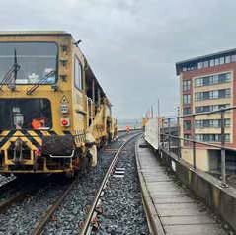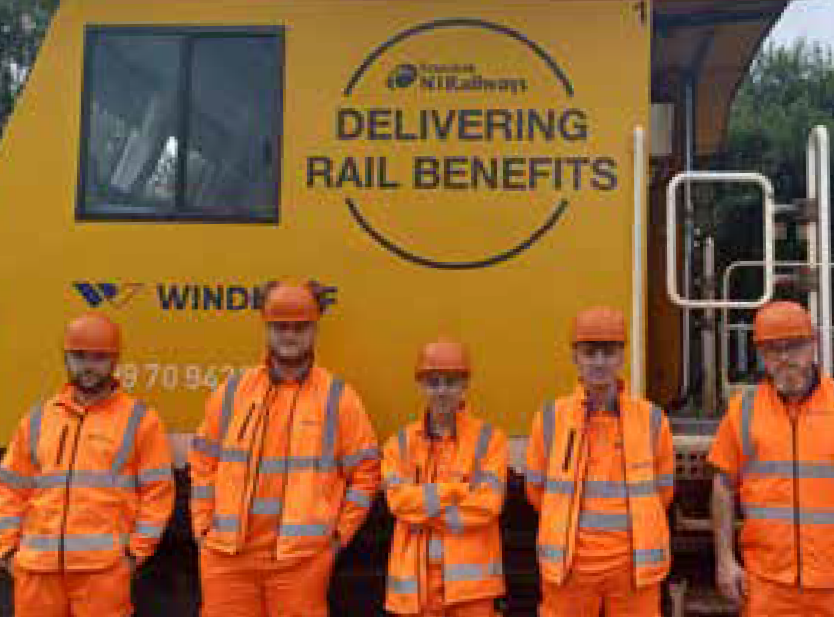

#### Telecoms and Electrical Engineering (Signalling and Telecoms)

Apprentices in Telecoms and Electrical Engineering (Signalling and Telecoms) will cover the installation, maintenance and repair of safety critical Signalling and Telecommunications equipment across the network. This vital function requires diversity of experience and competency, responding to business needs 24/7.

Apprentices will be based in Greater Belfast or Ballymena with travel throughout Northern Ireland as required.

Training will cover a range of competencies, including Signal Maintenance and Telecoms and will take 4 years to complete before being fully qualified as a Signalling & Telecoms Technician.

To assist with the growing levels of performance demands, we require innovative, committed team players who will develop into competent Signalling & Telecoms Technicians. Apprentices commence at ONC Level and should attain HNC Level in Electrical and Electronic Engineering by the end of the Apprenticeship with Belfast Metropolitan College one day a week. If successful opportunities would be considered to progress towards higher level sponsored learning within Engineering (Electrical and Electronic). Further development is also possible with options to attain Chartership and Degree qualifications.

## BENEFITS

* Increments on pay rates (hourly rate increases by level and discipline)
* Attractive NILGOSC pension including employer contribution
* Minimum of 25 days annual leave plus minimum 9 statutory holidays
* Diversity and inclusion networks and initiatives
* Monthly wellbeing initiatives
* Employee benefits scheme offering many discounts including Hapi App: savings on shopping, eating out and entertainment with cinema deals, sports, music and technology offers
* Access to Cycle to work scheme enabling you to purchase equipment up to the value of £2000 and an electrically assisted bike through salary sacrifice.
* Confidential counselling service
* Opportunity to get involved in charity fundraising and social value initiatives
* Volunteering opportunities

## LOCATIONS

**Locations of Infrastructure and Projects Apprenticeship Opportunities**

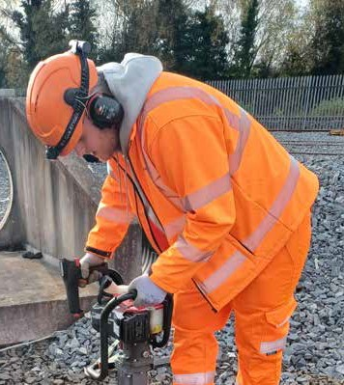

Based within the Greater Belfast Area or at Translink Depots in Portadown, Ballymena and Coleraine with travel throughout Northern

Ireland across the Translink bus and rail transport network. On occasions you may have to travel outside Northern Ireland.

### What activities/projects have you been involved in as part of Apprenticeship training?



MEET AN APPRENTICE

**Danny McGinley**

YEAR 1 APPRENTICE

Rail Engineering (Track) (Permanent Way)

Since I came into the Apprenticeship programme I have been involved in a wide range of training activities. The training relates to track maintenance, track repair, track safety and first aid training.

### What experience/interest have you found helpful for Apprenticeship?

There is a great mixture and combination of hands on and classroom training. The team are really supportive and want you to improve your skills and succeed.

Danny McGinley joined the Permanent Way Department in August 2022, when he commenced Year 1 of the Rail Engineering (Track) Apprenticeship.

**‘‘**...Don’t hesitate to apply

### Have you any suggestions/advice for those who are considering Apprenticeship?

Don’t hesitate to apply! The Apprenticeship is open to everyone.

### Highlights of your Apprenticeship to date:

The highlight of my Apprenticeship to date has been getting trained in a previously unseen profession that requires specialised skills for specialised field of work.

### What activities/projects have you been involved in as part of Apprenticeship training?

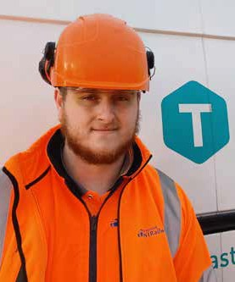

MEET AN APPRENTICE

**Niall Dornan**

YEAR 1 APPRENTICE

Rail Engineering (Track) (Permanent Way)

I have been involved in teambuilding exercises, carrying out tasks on track such as maintenance and repair of assets and I attend college one day per week to complete a rail specific diploma.

### What experience/interest have you found helpful for Apprenticeship?

I have learned how to use different complex tools and experience nightshift. I have also had the opportunity to experience various types of machinery used on the railway.

Niall Dornan is also undertaking his first year of the Permanent Way Apprenticeship training programme for Railway Engineering (Track). Building knowledge and skills in the inspection, maintenance and repair of railway track assets and components.

### Have you any suggestions/advice for those who are considering Apprenticeship?

Definitely go for it! The Apprenticeship allows you to expand your knowledge in maintenance and gives you hands on experience.

### Highlights of your Apprenticeship to date:

The highlights for me so far have been working as part of a team in the squads, every day is always different and gaining knowledge of the train network.

**‘‘**

# ...every day is always different

### Why did you apply for the Translink Infrastructure and Projects Apprenticeship?



MEET AN APPRENTICE

**Caragh Woods**

YEAR 1 APPRENTICE

Electrical Engineering (Signalling & Telecoms)

I have always had an interest in Engineering and I thought this Apprenticeship would be a great way to earn while you learn and obtain valuable on the job experience, all while working for a great company.

### Did you have any special interests/experience that helped you pursue the Apprenticeship in Signalling and Telecoms?

I have always enjoyed engineering, having completed A-Levels in Engineering. This definitely helped me when coming into an engineering role as I already had some of the basic knowledge of electronics which is needed for this job.

Caragh Woods is currently training within the Signalling and Telecoms Department. Caragh commenced her first year as an Electrical Engineering Apprentice in

August 2022.

**‘‘**

# ...a great way to earn while you learn.

### What have you enjoyed the most and also found challenging as part of your training?

I have enjoyed learning about the various types of equipment throughout the railway and attending any equipment faults, being able to use all of the skills and knowledge I have learned so far. However, it can be challenging as there is still a lot to learn, which will take time.

### Do you have any advice for someone thinking of applying for the Apprenticeship:

Do it! It is a great way to improve skills, gain knowledge, and valuable work experience, all while completing a qualification. It is a great way to earn while you learn

Ciarnan McKeating is also training in Electrical Engineering and covering the installation, maintenance and repair

of safety critical Signalling and Telecommunications equipment throughout the network.

**‘‘**

## ...a great way to feed into Engineering

### Why did you apply for the Translink Infrastructure and Projects Apprenticeship?

I saw it advertised and thought it was a great way to feed into the working world while gaining a qualification. I have always had an interest in Engineering and knew that this role was one that suited me. I’m keen to learn and better my understanding of Engineering and in this Apprenticeship you pick up something different nearly every day.



MEET AN APPRENTICE

**Ciarnan McKeating**

YEAR 1 APPRENTICE

Electrical Engineering (Signalling & Telecoms)

### Did you have any special interests/experience that helped you pursue the Apprenticeship in Signalling and Telecoms?

I enjoy the physical (hands on) aspect to the job. I’d say my experience is limited to helping round the house with things like wifi routers etc. Before Translink, I studied Politics at university and quickly discovered that a desk job was not for me. This Apprenticeship has definitely been a great way to feed into Engineering.

### What have you enjoyed the most and also found challenging as part of your training?

To be honest this is a complete career change for me so every day is enjoyable as I’m constantly learning. I love to see how the communication systems work across the network and also get to experience how we keep people safe on the railway (including ourselves) while keeping trains running smoothly.

### Do you have any advice for someone thinking of applying for the Apprenticeship:

I would 100% recommend this opportunity to anyone who is willing to put in the work both on site and in college. It’s a great opportunity for anyone with a

general interest towards Engineering and it’s a kick start for your career in a fast growing and distinguished company.

### Why did you apply for the Translink Infrastructure and Projects Apprenticeship?



MEET AN APPRENTICE

**Alex Buchanan**

YEAR 1 APPRENTICE

Civil/Structural Engineering (Structures)

I had an interest in Engineering and the Translink Apprenticeship was an attractive opportunity to gain work experience while I work towards a degree.

### Did you have any special interests/experience that helped you pursue an Apprenticeship in Civil Engineering?

I always had an interest in structures and the world around me, although no previous Engineering experience.

Alex Buchanan joined the Structures Department of Translink in September 2022 as part of the Civil/

Structural Engineering Apprenticeship, assisting with site examinations and getting hands on experience with public transport infrastructure projects.

### What have you enjoyed the most and also found challenging as part of your training?

I have enjoyed going out on site visits and expanding my knowledge on different structures and learning about how they support the railway.

### Do you have any advice for someone thinking of applying for the Apprenticeship:

I would definitely recommend the Apprenticeship to anyone considering. It’s the perfect opportunity to gain experience and earn while you learn.

## ...I would definitely recommend the Apprenticeship

**‘‘**

APPRENTICE PROFILE

GATEWAY TO YOUR FUTURE

Infrastructure and Projects Apprenticeships with Translink 2023

#### Minimum Criteria

* Aged 18 years old or over (on or before the 1st August 2023; and on or before 1st September 2023 for Civil and Structural Engineering).
* All applicants require a minimum of 5 GCSE’s at grade C or above (or equivalent qualification) including English and Maths or be expecting to receive these by August 2023.
* Proof of qualifications will be required as well as reference from school or college.
* Applicants to self-enrol/register on courses and provide confirmation of reservation with college/university for September 2023.
* Applicants must have experience of using Microsoft Office packages
* Able to demonstrate examples of a practical hands-on approach
* Team player with a positive attitude
* Committed, self-motivated and willing to respond to the needs of the Apprenticeship scheme
* Excellent communication skills
* Understand how to provide an excellent customer experience

#### Desirable Criteria

* Minimum of grade B in Maths is desirable for Civil and Structural Engineering
* Experience of working in an engineering environment and/or possess a relevant engineering qualification.

#### How to Apply

Please visit our website: [www.translink.co.uk/apprenticeships](http://www.translink.co.uk/apprenticeships) and complete the online application form.

EQUAL OPPORTUNITY POLICY





*Translink values its employees and is committed to building a diverse and inclusive workplace that attracts, retains and develops the best talent. We are an equal opportunities employer, in this instance applications from women would be particularly welcome.*

