The Letter
The Dog has chewed the letter. Some of the words are missing.
Fill the gaps with words which make sense.
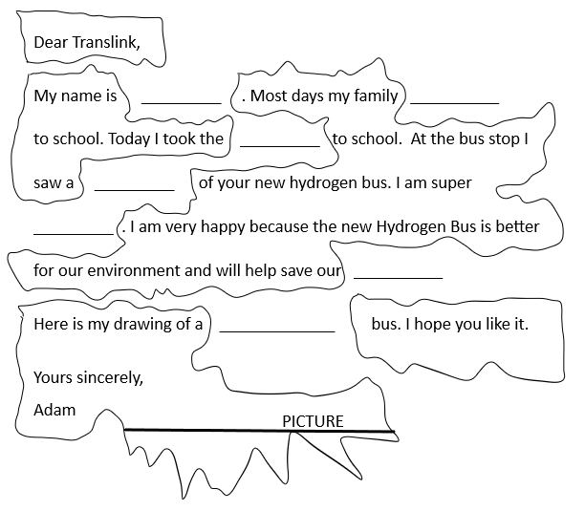
The picture is missing. Draw a new picture.
WORK-BANK
Picture
Walk
excited
Adam
drawing
like
hydrogen
Bus
planet

Extension
Copy the letter.
Write other words in the gaps.

