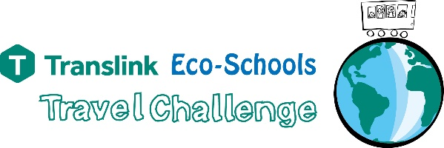 | 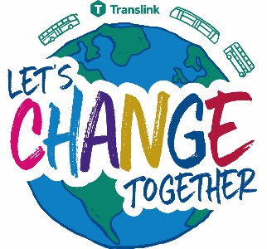
CHALLENGE INSTRUCTIONS
- The Translink Eco Schools Travel Challenge is a 2 week challenge running ALL YEAR to allow your school more flexibility on when to take part.
- You can complete your Challenge in any 2 week period you chose as long as you submit the results by the deadline of Monday 16th May 2022 which means your latest start date must be by Monday 2nd May 2022.
- Please feel free to run the challenge for as long and as often as you like – you can do more than two weeks if you wish. Two weeks is the minimum time required to enter the competition.
- The Challenge can be done by one class, lots of classes, the whole school, a group of enthusiasts – whichever works best for your school – obviously the more the merrier.
- The Challenge will help your school, pupils and parents to consider more environmentally friendly and healthy ways to travel to school– walk, bike, bus, train, scoot – it’s all good!
- The Challenge will help you work towards your Eco-Schools Green Flag Award.
- The Challenge is a great numeracy task sustainably in a real world setting.

Pupils should keep track of their transport methods over the 2 week challenge using the individual tally charts, and then compile their class results and submit them via the Eco-Schools online Data Zone – details below.

Please use the individual pupil tally charts and the classroom one in the toolkit for this year’s challenge.

recording your Translink Travel Challenge results

- In order to make a good before and after comparison of your pupils’ efforts in the Travel Challenge you will need to provide 2 surveys
- Before - ‘My Old Travel’ an estimate by the pupils of how they have travelled in the 2 weeks prior to the challenge and
- After - ‘My New Travel’ a tally and total of their journeys during the challenge which will hopefully show an increase in sustainable journeys.

- There are 2 ways (check the toolkit) of keeping track of which modes of transport your pupils are using
- Individual pupil tally charts (this can easily be used at home while walking to the shop or simply for a walk somewhere with family or a friend).
- Classroom chart.

Each pupil should be recording 20 journeys before the challenge and 20 journeys during the challenge. 1 journey = a trip to or from school. So total journeys over a 2 week/10 day period should be 20 journeys i.e. in and out each day. Journeys outside the school gates as a daily walk will be counted too this year, so encourage your pupils to go for a stroll with their parents or a friend to a public park nearby for instance.

Below is an example of how a completed individual pupil tally chart might look.

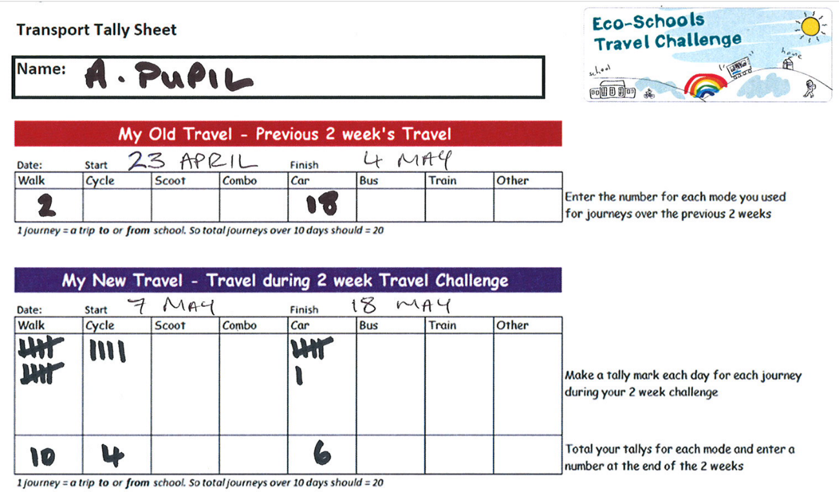

Compiling your class Travel Challenge Results

Once your pupils have completed their Travel Challenge you will need to compile their results to reflect the class as a whole.
You will want the totals for the modes of transport for the 2 surveys, before and after the challenge, across the class.

When using the tally sheets each pupil can call out, or write on the board, their totals for each mode of transport for the before and after surveys. These totals can then be added up. There is a Class Total sheet in the toolkit for you record the total figures on.

Remember each pupil should have accounted for 20 journeys in each survey, before and after, so you can do a quick calculation to check you have the right amount for the number of pupils i.e. 30 pupils should have done 600 journeys. Of course you may have had some absent pupils in which case there may be a slight difference.

Submitting Your Results

Submitting your results not only enters your pupils and classroom into the running for some great Translink Travel Challenge prizes, it also completes an important step of your Eco-Schools journey, “Monitoring and Evaluation” and will be a great help for your future Green Flag applications.

Now that you have compiled your result into a class total, please submit the results of your 2 surveys, before and after, in the online Data Zone of your School Zone. It will be simple and fast.

- Go to www.eco-schoolsni.org and log in (if you have forgotten your password click on the Forgotten Password option; this will direct you to a reset link)
- In the School Zone (Red Box) go to the Data Zone and click on Transport
- Now simply complete the requested information, start finish dates, number of pupils, name of the initiative “Translink Travel Challenge” and then your totals for each mode of transport and hit submit – here is an example:

Viewing the survey you have submitted will allow you to see what percentage of your journeys were sustainable. Hopefully you will see an improvement from your before survey and your after survey. This is the time for you and the pupils to evaluate/discuss the results and celebrate success with the whole school and wider community.

Once these results are in your Data Zone they will be automatically attached to future Green Flag applications.

Remember to submit your results via the Data Zone by Monday 16th May 2022.

Best Pupil category

As we won’t see your individual pupils’ results with this submission system we are relying on you to nominate your school’s Transport Hero. One pupil from Northern Ireland will be chosen based on the information you submit for a prize and recognition at the Translink Travel Challenge Awards Events (see power point in the toolkit to know the prize categories).

We know every pupil will literally be going the extra mile for the challenge but sometimes there is a stand out pupil who deserves a little pat on the back. So if you have such a pupil please nominate them for the Best Pupil prize by emailing us a short description of why they are so fantastic and perhaps some photos too. Send this by email to eco-schools@keepnorthernirelandbeautiful.org by Monday 16th May 2022 for consideration.

FURTHER INFORMATION and teaching resources

Don’t forget to check out the complementary teaching resources for the Travel Challenge available on the Translink website www.translink.co.uk/ecoschools KS1-KS3 and more information on the new Translink Changemakers Programme.

If you require further information or guidance on taking part in the Translink Eco-Schools Travel Challenge, please contact Eco-Schools staff via email Charlene.McKeown@keepnorthernirelandbeautiful.org

The Translink Eco-Schools Travel Challenge is open to all schools across Northern Ireland.

We hope you enjoy participating in the Translink Eco-Schools Travel Challenge!

#letschangetogether

