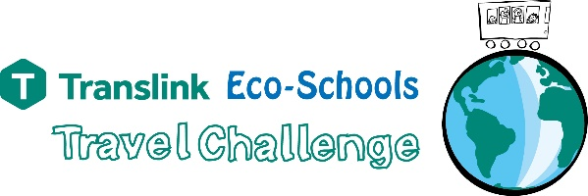 | 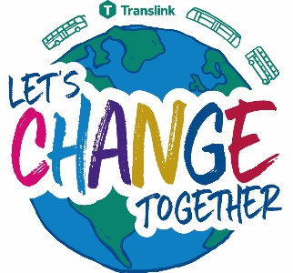
______DATE______

Dear Parent/Carer,

This year our school is participating in the Translink Eco-Schools Travel Challenge being run in partnership by Keep Northern Ireland Beautiful Eco-Schools and Translink.

Children in class _______(participating class name)_______ will be asked to take part in this challenge over a 2 week period starting on ________(insert date)________.

Given there is a greater focus on climate action in the media and in general conversation this Challenge is an excellent way for your child to engage positively in a way that enables them also to make healthier choices about how they get to school.

We will look at what transport pupils currently use to get to and from school, or when enjoying the great outdoors (this year you can include your children’s outdoors journeys by walking, scooting, cycling, by train) and ask you and them to try and make sustainable improvements during this period and beyond.

Following the current safety rules when taking the bus and/or the train, walking, scooting or cycling – even once a week can make a big difference!

This is a fantastic opportunity for our school to work towards becoming more environmentally sustainable by reducing carbon emissions caused by traffic and is a positive step towards reducing car congestion around the school. It is also a healthy and sociable option for our pupils. We will also be using the challenge as a means to achieving the prestigious Eco-Schools Green Flag award.

Joining the Travel Challenge is free for the school and there will be special awards ceremonies in June 2022 to present prizes to the top participants from across your county.

There are some great prizes based on sustainable transport to be won for the school and for an individual pupil and their family.

We hope you will support our Translink Eco-Schools Travel Challenge!

For further information on the Translink Eco-Schools Travel Challenge please speak to ____(insert name)____ our Eco-Schools Co-ordinator or to me. You can also find more information on the Translink Eco-Schools webpage at www.translink.co.uk/ecoschools Also on this webpage you can find details for post-primary school pupils of Translink’s new Changemaker Programme.

Yours Sincerely

INSERT NAME OF SCHOOL PRINCIPAL

