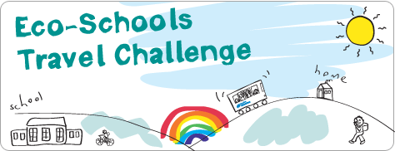

Teachers’ Tips
Thank you for deciding to take part in the Translink Eco-Schools Travel Challenge this school year. Great to have you on board. You will have seen in the news and all over social media of the need for positive climate action and that’s exactly where this challenge fits in!
Outlined below are the best ways to encourage pupils, parents and other teachers to take part, however, we are also here should you need us. Your key contact is: Charlene McKeown Charlene.McKeown@keepnorthernirelandbeautiful.org she will be able to help you with all your queries and requirements.
The Translink Eco-Schools Travel Challenge Toolkit includes a letter to parents which you can adapt to suit the needs of your school.
Perhaps some of the following ideas will help you and the parents to improve the school run and encourage everyone to get out of the car and stretch their legs!
Really good reasons to do the travel challenge –
- It’s healthy
- It’s good for the planet
- It’s social and fun – have a good chat on the way!
- It could save petrol money
- Pupils who walk or cycle to school are more alert and do better in class
- It will help solve congestion at the school gates
- It helps Primary pupils transition to travelling to Post-Primary Schools
- It will help your work toward an Eco-Schools award
- You could win a prize
Ideas for your travel challenge –
Create a ‘Walking Bus’
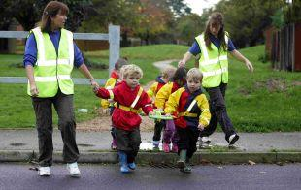
This is a great idea for younger pupils or busier travel routes where parents may not feel confident in letting their children walk on their own. Teachers, parents or governors can take the position of ‘Driver’ at the front of the queue and ‘Conductor’ at the back. The bus might take a specific route through your area to pick up pupils or walk from a designated drop off point. All the pupils walk together in their assigned small group, which keeps them safe. High-visibility vests are a good idea if you have them, particularly for the ‘Driver’ and ‘Conductor’. A small reward for those taking part is a good incentive.
Park and Stride
If the area around your school is really congested with school run traffic at drop off and pick up times have a look further away for an area where parents could safely park and the pupils could walk the remainder of the way. Quite often local shops with big parking areas might be willing to help you with the Translink Eco- Schools Travel Challenge by letting parents use their car-park – after all it’s good for business. Perhaps a local church or sports centre could help you in the same way.
Have a WOW day
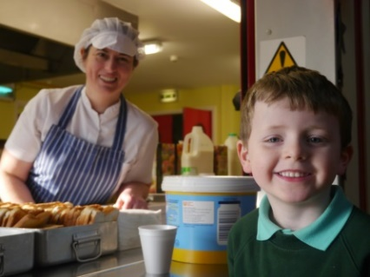
WOW stands for Walk/Wheel Once a Week or Walk/Wheel on Wednesdays. Encourage everyone to take part – parents too! Make it a real event, perhaps with fancy dress and an incentive such as a sticker or small prize for those who take part. Food always works well too! How about a ‘bike for breakfast club’ or a favourite lunch dish on your big day?
Get transport savvy – Something interesting to learn while being at home!
Go online with your pupils in class, or encourage them to investigate at home with parents, to research the bus and train routes in your area. Use the online travel planner and timetables at www.translink.co.uk to work out a transport plan to and from school. Younger pupils can travel in assigned groups or with parents. For Primary School pupils it’s great preparation for future travel to Post-Primary education. It’s also a great way to use maths skills and build independence and confidence.
Set a target – be serious about your challenge!
A little competition always helps pupils (and teachers!) to strive harder. Why not set up a prize for the best pupil effort in your class or at home each week of the challenge or compete between classes in the school. Setting a target like a certain amount of eco-kilometres reached by your class is great encouragement and a good use of maths skills too. Your excel Travel Challenge worksheet should help you work this out - for example, Magherafelt Primary School set themselves a ‘Lap the Lough’ challenge and managed to walk the distance around Lough Neagh three times during their challenge! How many kilometres could your class save? Why not counting also the kilometres while enjoying the great outdoors for a walk with their family?
Information on all the prizes is provided in your Translink Eco-Schools Travel Challenge Toolkit or on www.translink.co.uk/ecoschools
Teaching Resources -
Re-enforce your travel message by using the specially developed teaching resources for KS1, KS2 and KS3 as well as Translink’s new Changemaker Programme available at www.translink.co.uk/ecoschools. The resources contain lesson ideas, activities and fun worksheets investigating sustainable travel issues.

