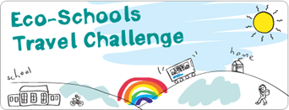

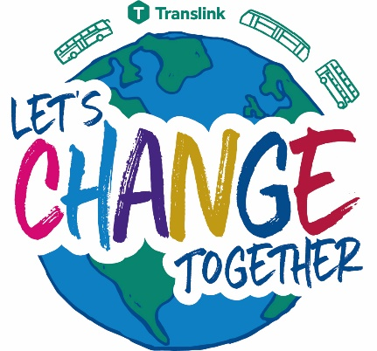

Now enter your results into the Eco-Schools online Data Zone to submit your Translink Travel Challenge results

[www.eco-schoolsni.org](http://www.eco-schoolsni.org)

Remember to submit your results by

**Monday 16th May** to be in with the chance to win some super prizes.