Infrastructure and Projects Directorate Business Plan 2021/2022

Infrastructure and Projects Directorate Business Plan 2021/2022 3
2 Infrastructure and Projects Directorate Business Plan 2021/2022

Contents
- Foreword and Welcome
- Purpose
- The Translink Corporate Vision and Values
- Introduction
09 Assets
11 Business Strategy, Objectives and Plans
13 Organisational Structure
- Financial Overview for 2021/2022
- Appendices
16 Appendix A: Glossary of Terms and Abbreviations

- Appendix B: Overview of the NI Mainline Rail Network
- Appendix C: Overview of Bus Property
- Appendix D: Overview of the Directorate’s Role as Railway Infrastructure Manager for
Northern Ireland
- Appendix E: Revenue Budgets 2021/22
- Appendix F: Capital Investment 2021/22
- Appendix G: Group Structure

4 Infrastructure and Projects Directorate Business Plan 2021/2022 Infrastructure and Projects Directorate Business Plan 2021/2022 5

Foreword and Welcome Purpose

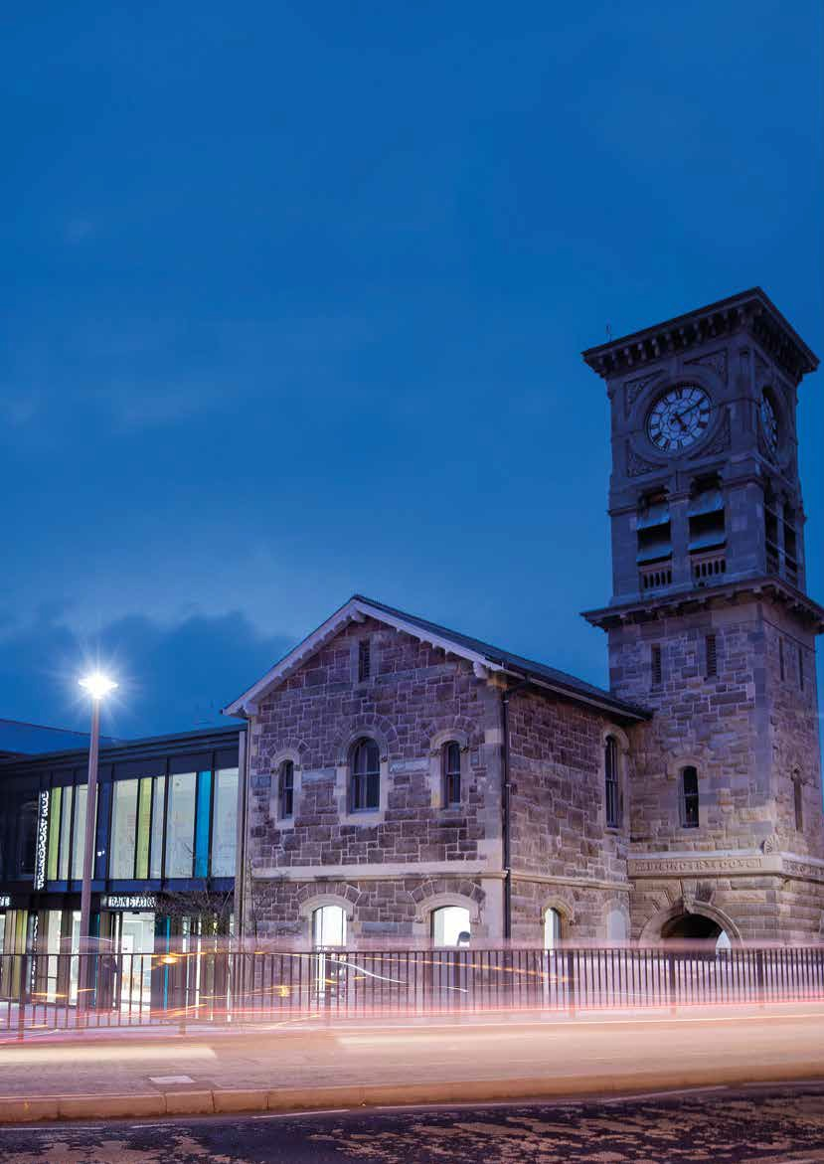I am pleased to again present this Business Plan for the Infrastructure and Projects Directorate (IPD). As in previous years,
the purpose of this plan is to provide a high-level overview of the Infrastructure and Projects Directorate’s organisation and key activities. The Plan provides detail on risk and assurance management, resources, budgets and plans for the 2021/22 financial year.

The last 18 months have seen many of our staff and contractors adapting to new ways of working. We have worked together diligently to allow public transport to continue, and to develop new projects despite the exceptional circumstances of
COVID19. I have been pleased with the completion and ongoing progress of important projects across all IPD departments, many of which have required significant cooperation within the Directorate. These works included eddy current testing and rail milling, Cullybackey area signalling and level crossings renewals, emergency sea defence repairs, car park resurfacing and bus safety improvement works.

Phase 2 of the North West Multimodal Transport Hub project was completed in November 2020, having opened to passengers in October 2019. This £27 million project provided new passenger facilities inside the restored Grade B listed building, associated track and platform works, redesign to allow improved bus turning facilities and a greenway link to the city centre via the Peace Bridge.

Work on the Belfast Transport Hub is on schedule. This flagship project will provide major regeneration and improve connectivity in the city. Enabling works have continued throughout the pandemic, with the main construction due to commence in early 2022.

During 2021 Translink launched its Climate Positive strategy setting out how it intends to meet ambitious carbon reduction targets leading a Carbon positive position by 2050. We in IPD have in turn been developing our strategies in order to complete the significant body of infrastructure projects required to facilitate Carbon reduction across Translink.
To ensure the leadership required for such a long- term commitment we have recently established our Infrastructure Climate Positive Steering Group with representation across the division and 8
separate workstreams including Property, Signalling & Telecoms, Renewables Microgeneration, Infrastructure linked to our EV and Hydrogen bus fleet, Rail decarbonisation, biodiversity and Energy Procurement. We now look forward to establishing and implementing detailed strategic plans in each of these areas during 2022 and taking our first steps toward the 2030 milestone of 50% reduction in carbon emissions. This will be an exciting and
challenging journey which we will travel with energy, innovation and enthusiasm and we look forward to providing a Greener Infrastructure for Translink and our passengers.

Our Sponsor Department within the Department for Infrastructure is supporting us in our strategy to
address the backlog and achieve a steady state. This funding has enabled a number of works to progress which has led to a substantial increase in worksites across the rail network. IPD is also now contributing to the Translink-wide development of a whole lifecycle Asset Management approach.

Our attention will now be on “Building Back”, as focus shifts from the recent restrictions to the return to normal ways of working and travelling. I would also like to take this opportunity to welcome new
colleagues and finally to thank you for your continued support as we navigate the coming months.
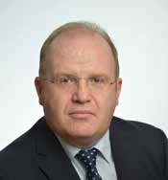

John Glass, Director of Infrastructure and Projects
The purpose of this Business Plan is to provide a sound footing for the budgeting, planning and resource-identification needs of the Infrastructure and Projects Directorate (IPD)
in its contribution to the delivery of the Translink Group’s Vision and Corporate Objectives. This plan includes details of investment programmes and describes the Business Strategies and Objectives for the Directorate, the means by which they shall be achieved and the departments responsible for their delivery.

6 Infrastructure and Projects Directorate Business Plan 2021/2022 Infrastructure and Projects Directorate Business Plan 2021/2022 7

The Translink Corporate Vision and Values Introduction

The Vision
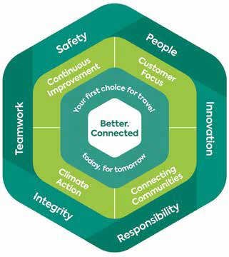
This is a high-level statement of what the organisation will achieve. The Mission describes what will be done by the organisation to deliver the Vision. The Values describe the attributes that the organisation will employ in delivering the Mission.

Our Vision
To be your first choice for Travel in Northern Ireland.

Our Mission
To deliver a transformation in public transport, providing integrated services which connect people, enhance the economy and improve the environment, enabling a thriving Northern Ireland.
This is the Business Plan for the Infrastructure and Projects Directorate operating within the Translink Group for the 2021/22 financial year.

Public Transport:
Northern Ireland Context
The arrangements for delivery of Public Transport in Northern Ireland are structured as shown in Figure 2, below. (Correct at time of going to print.)

Infrastructure Executive Mandate
On behalf of the Translink Group Chief Executive, the Director of Infrastructure and Projects undertakes the functions of:
- Railway Infrastructure Manager (IM)
- Network Assurance and Safety Manager
- Bus Property Manager
- Rail Property Manager
- Systems and Performance Manager
- Project Delivery

Our Values
The ‘Translink SPIRIT’ is a set of guiding principles that are a fundamental part of everything we do. These core values are embedded in the culture of our organisation and enable us to lead, inspire and succeed in delivering our goals for Translink.

Our people are passionate about providing excellent public transport and we do this through our Translink SPIRIT.

Figure 2: Public Transport in Northern Ireland

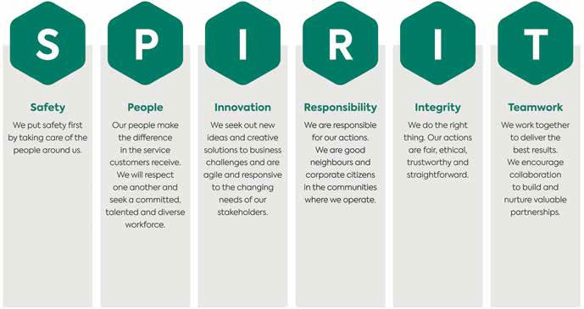
*Details in Appendix G.
Translink Group*
Rail Services
Infrastructure and Project Delivery
Bus Services

Department for Infrastructure

8 Infrastructure and Projects Directorate Business Plan 2021/2022 Infrastructure and Projects Directorate Business Plan 2021/2022 9

Line-of-Sight Management
There is a Corporate Vision and Values to which IPD has aligned its Vision, Objectives and Values. Organisational objectives feed clearly into asset management strategies, objectives, plans and day-to-day activities. The overall asset management strategy includes strategies for managing assets and strategies
for improving asset management. This includes whole life cycle asset management planning such as create/ acquire, operate, maintain, renew/dispose.

Customers
Bus Operations Railway Undertakings Commercial Tenants

Assets

The Infrastructure and Projects Directorate is responsible for all infrastructure and property assets which support Public Transport in Northern Ireland.

Overview
The assets include 206 route miles (331 route/ km) of mainline railway and 400 properties across 131 locations (including all associated systems).

- Office accommodation.
- Park & Ride facilities.
- Property workshop and vehicles.
- Other NITHC properties.
- Management of commercial tenancies.

Signalling and Telecoms

Other Stakeholders
NI Assembly Local Councils Neighbours Irish Rail Landowners Tenants
3rd Party Works

Suppliers
Goods, Works, Services

Change to Infrastructure and Project Delivery Directorate

Corporate Shared Services
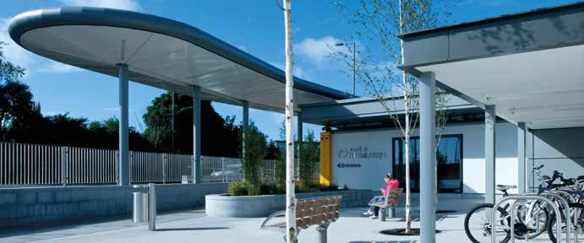
Group, Safety, Health, Environment, Human Resources, Information Services, Legal / Governance, Finance, Marketing
Rail Authorities
DfI ORR
Safety Authority Competent Authority

Statutory Authorities
HSENI
DfI ORR
DoE DARD
Appendices B and C provide overviews of the rail network and bus property locations, respectively. The operation of the railway network is the responsibility of the Infrastructure and Projects Directorate as the Infrastructure Manager (IM) for mainline rail in Northern Ireland. Bus and train
services are operated by the operating companies. The main assets and functions for which the Directorate holds responsibility are outlined below.

People
The infrastructure and property assets are maintained, operated, renewed, upgraded and developed by our diligent, competent staff.
The organisational structure and the continual development of our staff (e.g., through vocational training) is a key part of delivering our asset management obligations (see also Section 4).
The Infrastructure and Projects Directorate is set out as in Figure 4.

Permanent Way (Track)
      - Fixed assets (e.g., mainline track, sidings, drainage, lineside fencing and gates, points and crossings, lineside signage, level crossing surfaces).
      - On track plant (e.g., tamping and lining machines, ballast regulator, road-rail machines, ballast wagons).
      - Other (e.g., squad vehicles, small plant, stores and depots).

Structures
      - Bridges, viaducts, culverts, tunnels.
      - Earthworks, sea defences and retaining structures.
      - Platform copings.
      - Signal structures (signal posts, gantries).
      - Other miscellaneous structures (e.g., water towers).

Estates and Property
      - Maintenance of bus and train stations, depots and garages, train halts, buildings and lands (e.g. signal cabins, station car parks).
      - Signal and crossing cabins, and signalling centre
systems (e.g. interlockings, panels, telephone concentrators, train describers).
      - Lineside signalling assets (e.g. signals, points, train detection, train protection and warning systems).
      - Telecoms assets (e.g., lineside telephones, transmission equipment, telecommunications cabling/optical fibre, train radio system).
      - Other (e.g. squad vehicles, stores and depots).

Head of Major Projects, Contracts & Frameworks
      - Undertake and deliver major projects.
      - Contract management and commercial support for all capital projects and major frameworks.

Network Assurance and Safety
      - Manage the Infrastructure Safety Management System (ISMS).
      - Provide technical and safety advice in matters relating to risk management, business change, occupational safety, rules and regulations and User Worked Crossings.

Systems and Performance
      - Asset Management.
      - Track Access and capacity allocation.
      - Performance monitoring.
      - Digital Information Management.
      - Support services for the Directorate.

Business Change
      - Facilitation and tracking of Strategies, resourcing and competency to enable major change and modernisation programmes
      - Leading the strategic direction of change around our Climate Positive obligations

Asset Management
The Infrastructure and Projects Directorate is responsible for the safety and performance of

10 Infrastructure and Projects Directorate Business Plan 2021/2022 Infrastructure and Projects Directorate Business Plan 2021/2022 11

the Infrastructure and Property Asset Base; the Infrastructure Engineering and Property
Departments routinely inspect and maintain the thousands of infrastructure assets to ensure their
Management Policy and Objectives was issued in July 2020. The policy defines the “mandated requirements, overall intentions/principles and framework for control of asset management”.

Business Strategy, Objectives and Plans

availability for operational use. The Departments’ activities also include management of seasonal and adverse weather issues such as snow, ice, flooding and high winds. These activities are often invisible to the asset user but are an invaluable part in the
delivery of the Values and Objectives of the Translink Group. As part of the Organisation’s commitment
to continual improvement, an asset management regime for the Directorate is being developed.
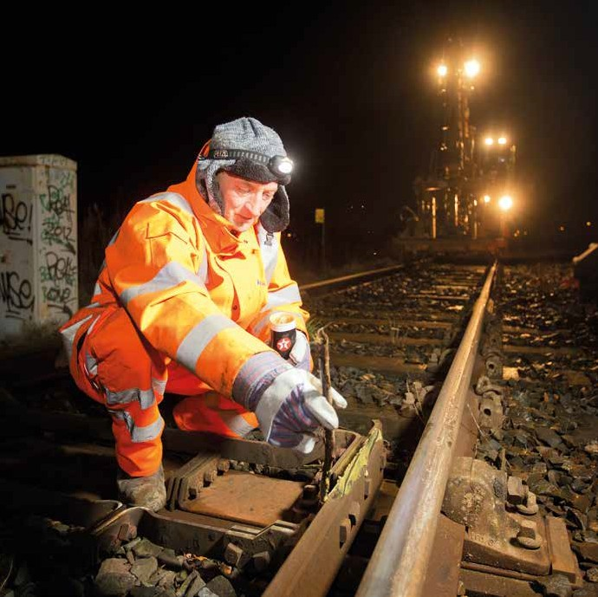
The aim is to develop a system compatible with ISO55000 with a view to potentially obtaining formal accreditation in future. A Corporate Asset
IPD are developing a 5-year “Route Map to Asset Management Maturity” to achieve the policy and objectives. This will be fully integrated with the other Translink divisions to meet the overall needs of the business. Whilst there are some common
themes such as Asset Information, Risk Management, Asset Criticality, and Lifecycle costing, the specifics are different for each department. Individual departments are developing their strategies and plans to identify their respective priorities in relation to formal asset management.
This chapter sets out the Infrastructure and Projects Directorate’s responsibilities.

Directorate Responsibilities
Translink Infrastructure and Projects Directorate is responsible for:

- The provision and maintenance of bus infrastructure assets;
- The provision, maintenance and operation of rail infrastructure assets;
- Project Delivery;
- Financial management (including ensuring the IM achieves financial balance).

Appendix D provides an overview of IPD’s role as Infrastructure Manager (IM) for the mainline railway network in Northern Ireland.

Business Strategy
The Infrastructure and Projects Directorate Business Strategy is four-fold, based upon:

Steady State Operations
  - Efficiently maintaining the existing infrastructure and property to suitable technical and operational standards.
  - Replacing, refurbishing or renewing assets as they approach the end of their useful life based upon the lifecycle balance of economy, safety, availability, reliability and ongoing maintenance.
  - Maintaining a balanced budget whilst seeking to improve operational efficiency.

Service Development
Providing the optimal infrastructure and property capacity, quality and performance capability in response to service development objectives, within the constraints of available resources.

Risk and Assurance Management
Identifying the operational and business risks involved in delivering our services and assuring ourselves that we have suitable systems in place to adequately manage those risks.

Continual Improvement
To continually improve ourselves and our services to our customers and other stakeholders. An important aspect of this continual improvement in 2021/22 will be the alignment with the Company pledge to become Climate Positive and to drive positive change to a cleaner, greener transformation in public transport.

The following challenging targets have been set:

- 50% reductions in our current carbon emissions by 2030
- All our buses, trains and buildings to be Net Zero by 2040
- Climate Positive by 2050

As a first step in support of this, IPD has taken a major step towards reducing our carbon footprint with the introduction of 100% electric vans to our fleet of support vehicles.

12 Infrastructure and Projects Directorate Business Plan 2021/2022 Infrastructure and Projects Directorate Business Plan 2021/2022 13

Business Strategy, Objectives and Plans
The table below provides strategies and objectives which align with the Corporate objectives listed in Section 1.5.

Organisational Structure

This chapter describes the organisational structure of The Infrastructure and Projects Directorate.
Operational Excellence – Achieve excellence in service performance by driving continuous improvement in Safety, Punctuality and Reliability.
Implement a Lifecycle Asset Management system to support investment decisions on all assets. | 10% improvement in asset reliability and lifecycle costs. | Improve asset reliability.
 | 10% reduction in maintenance costs per kilometre. | Move towards ISO55000 and BIM compliance.
 |  | Develop plans for optimising Whole Life Costs.
 |  | Improve Infrastructure Asset Condition Recording.
Customer Satisfaction – To deliver an outstanding customer experience at every touch point.
Maintain and Enhance facilities for customers to support a consistent customer experience. | Maintenance standards have been agreed and are being rolled out. | Establish and implement a rebuild and refurb strategy.
 |  | Divisional ‘Go’ Safety and Corporate Responsibility Plans Developed.
Value for Money – To offer value for money to our customers.
Deliver Capital Investment Programme on time to budget and specification. | Top project priorities identified. | NIROC and BTH
Passenger Growth - To grow the number of passenger journeys on public transport, supporting a modal shift.
Develop Bus and Rail Fleet investment Strategies to support passenger growth and wider business strategies including decarbonisation of the bus/ rail fleet, zero emission technologies, customer experience/ product development, life cycle  cost optimisation and service performance. | Agreed Bus and Rail Fleet Strategies. | Undertake feasibility assessment for the electrification for the  NIR Network.
 |  | Led by a newly incorporated Steering Group, develop an Infrastructure Climate Positive Strategy to deliver the divisional carbon emissions reduction obligations

Overview
The structure and staff numbers in each department are outlined below.

Functional Coverage
The Assets described in Section 2 are managed within the functional departments illustrated in Figure 5, below.

People
There are approximately 316 people directly employed in the Infrastructure and Projects Directorate, as follows:

Department | No. of Staff
Belfast Transport Hub | 14
Commercial Contracts | 7
Infrastructure & Projects | 4
Infrastructure Systems & Performance | 5
Network Assurance & Safety | 15
Property | 61
Permanent Way | 89
Renewals | 31
Signalling & Telecoms | 69
Structures | 19
Business Change | 2

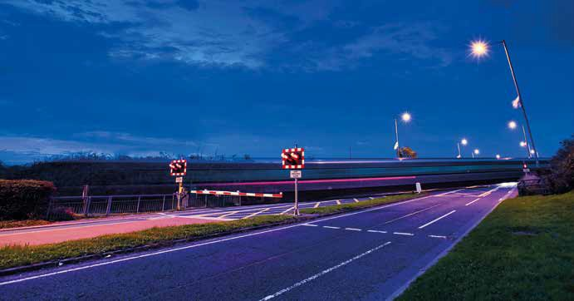
Controls
The main controls in place for the Directorate’s activities are outlined below.

Risk and Assurance Management
The identification and management of business risk and the associated assurance processes is integral to everything we do. The Divisional Hazard Register records items that could adversely affect any aspect of the business, including:

    - Safety
    - Finance
    - Governance/Compliance
    - Operational Performance
The register is updated quarterly, for each identified risk it details the description, the risk score, the current arrangements and proposed actions to eliminate, control or manage the risk, and the assurance arrangements in place. It also provides
a means of tracking progress against actions. Some of the key business risks being managed by IPD are:

- Level Crossings
- Resources
- Impact of Adverse Weather
- Asset Maintenance
- Compliance with the Management Statement and the Financial Memorandum
- Backlog of inspection and maintenance activities

Whilst it is important to manage all aspects of risk, safety is paramount – so much so that it is embedded as part of the Strategy, Objectives and
Plans set out in this Business Plan. Some processes such as the Infrastructure Safety Management System (I-SMS) are explicitly related to safety whilst in other areas it is implicit in the decision-making process. The I-SMS is currently being updated
and will be communicated in due course. At the time of publication, a significant proportion of IM assets have less than 5 years design life remaining.
In order to address this, a programme of work has been developed, including the identification and adoption of appropriate standards, and
discerning an appropriate balance between routine maintenance, refurbishment and renewal. As part of this programme, the DfI have been supportive in our work towards funding a “steady state”, where stable, year-on-year maintenance and renewal budgets are adequate for maintaining the asset base.

Directorate Safety Management System
A Safety Management System is maintained and applies to all the Directorate’s activities. It also incorporates the Infrastructure Safety Management System requirements.

Engineering Standards
A formal Standards Management Process is applied for Engineering Standards across the Asset Management Departments. As stated above, a plan has been developed to review the application of technical standards across the Directorate.

14 Infrastructure and Projects Directorate Business Plan 2021/2022 Infrastructure and Projects Directorate Business Plan 2021/2022 15

Finance
The Directorate manages its activities, so far as is practicable, to ensure adherence to the Management Statement and the Financial Memorandum (MSFM). All Directorate procurement activities (works, services,

Financial Overview for 2021/22

materials, equipment) are controlled through management processes and the Translink Group Integrated Electronic Financial Systems (Agresso IFS).
Figure 5: Organisational Structure
Head of Property & Estates
Network Assurance & Safety
Systems & Performance
Business Change
Belfast Transport Hub
Portfolio Management Office
Asset Management
Major Projects
Projects
Structures & Third Party Works
Signalling & Telecoms
This chapter provides an overview of the Infrastructure and Projects Directorate’s finances and major investment projects for this financial year.

Budgets
The current Capital budget for 2021/22 is
£116,539,959.

Revenue monies are used to provide the day-today operation and maintenance of the asset base, i.e., labour, materials, management and support. The capital monies will be used to renew, replace and upgrade the asset base. A further breakdown of the budgets into business areas is provided in Appendix E.

Financial Monitoring and Reporting
The Director of Infrastructure and Projects is responsible for the Directorate’s finances at Group Level. Within the Directorate the Heads of Departments are responsible as follows:

Revenue
Department Heads are responsible for the monitoring and financial reporting of all revenue- funded activities within their respective Departments to ensure that expenditure is within budget for each financial year.

Capital
Capital-funded activities are monitored, controlled and reported on via the Project Delivery Department and Project Accountant, as part of the Portfolio, Programme and Projects Management Procedures.

Financial Balance
The Director works actively in conjunction with the Group Finance Division, the Group Portfolio Office and individual Departments to monitor and review the overall budgets. This includes the requirement to ensure financial balance for the IM aspects of the Directorate’s activities.
Head of Rail Infrastructure Engineering
Maintenance
Permanent Way

Major Capital Investment Projects and Programmes
The main projects and programmes to maintain and develop the infrastructure and property being progressed this financial year are:

- Coleraine sidings
- Belfast Transport Hub
- Bridge refurbishment and strengthening programme
- Fortwilliam to Bleach Green signalling renewals
- Yorkgate Station redevelopment
- NIROC
- Rail milling programme
- STRXAM, Structures Examinations and Assessments
- Dark Arch Whiteabbey track renewal
- Cullybackey level crossings upgrade

A list of infrastructure and property projects is provided in Appendix F.
Group Chief Executive
Director of Infrastructure & Project Delivery
Head of Major Projects, Contracts & Frameworks
Contracts & Frameworks
Renewals

16 Infrastructure and Projects Directorate Business Plan 2021/2022 Infrastructure and Projects Directorate Business Plan 2021/2022 17

Appendices
A: Glossary of Terms and Abbreviations
B: Overview of the NI Mainline Rail Network
C: Overview of Bus Property
D: Overview of the Directorate’s Role as a Railway Infrastructure Manager for Northern Ireland

E: Revenue Budgets 2021/22 F: Capital Investment 2021/22 G: Group Structure

Appendix B: Overview of the NI Mainline Rail Network

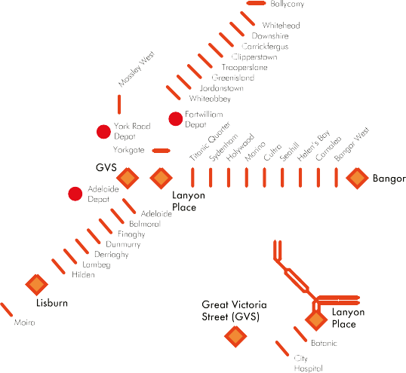Appendix A: Glossary of Terms and Abbreviations

Abbreviation/ Term | Explanation
AHB | Automatic Half Barrier
DARD | Department of Agriculture and Rural Development
DfI | Department for Infrastructure
DoE | Department of the Environment
HR | Human Resources Department
HSENI | Health & Safety Executive (Northern Ireland)
IFS | Integrated Finance System
IM | Infrastructure Manager – name given in legislation to the organisation responsible for the operation and maintenance of the railway network
IPD | Infrastructure and Projects Directorate
IS | Information Services Department
I-SMS | Infrastructure Safety Management System ISO55000 International Standards Organisation: Asset Management Standard
MSFM | Management Statement and Financial Memorandum – set out the arrangements for the management of the Translink Group of Companies
NIR | Northern Ireland Railways Company Limited, the Holding Company with NIR Networks and NIR Operations as its subsidiaries
NIR Networks | Northern Ireland Railways Networks Limited – IM for Northern Ireland mainline railways
NIR Operations | Northern Ireland Railways Operations Limited – RU for mainline public service train services in Northern Ireland
NIROC | Northern Ireland Railways Operational Control
NITHC | Northern Ireland Transport Holding Company
NT3 | New Trains 3 (Programme)
NWMTH | North West Multi-Modal Transport Hub
ORR | Office of Rail and Road
RU | Railway Undertaking – name given in legislation to an organisation responsible for the operation of passenger or freight train services
Safety Authority | Name given to the organisation responsible for regulating railway safety under legislation
SIP | Safety Improvement Programme
S&C | Switches and crossings
S&T | Signalling and Telecoms Department
SPAD | Signal Passed At Danger
Translink Group | The group of organisations that includes NITHC, NIR, Ulsterbus and Citybus (Metro)
UB | Ulsterbus

18 Infrastructure and Projects Directorate Business Plan 2021/2022 Infrastructure and Projects Directorate Business Plan 2021/2022 19

Appendix C: Overview of Bus Property

Key
Station(s)
••
Station with Park & Ride Engineering Workshop(s) Bus Depot(s) / Bus Park(s) Office(s)
•
•
Miscellaneous

N.B. Not on map: Stranraer (Scotland) ••
Limavady

Portrush
•
•C•ol•eraine
Ballymoney
•

Ballycastle
••

Cushendall
•

Appendix D: Overview of the Directorate’s Role as Railway Infrastructure Manager for Northern Ireland

There is a legal requirement for a role of Railway Infrastructure Manager (IM) to be performed. The IM provides access to Railway Undertakings (RUs), the operators of passenger and freight trains, to the railway infrastructure; the IM is responsible
for operation and maintenance of the railway
network. Within the Translink Group the executive

Infrastructure (Access, Management and Licensing of Railway Undertakings) Regulations (Northern Ireland) 2016 requires the IM to prepare a Business Plan. This Business Plan meets this requirement. The primary aims of the Directorate (in its role as IM) are:

- To ensure optimal and efficient use and development of the railway infrastructure; and
- Financial balance between income and expenditure, in so far as enabled by the Department for Infrastructure (DfI).

Strabane
•••

Derry - Londonderry
•••
Claudy
•
•••

Dungiven
••

Kilrea
•
Portglenone
•

Ballymena
•••

Larne
•••
responsibility for the IM’s tasks falls to the Director of Infrastructure and Projects. The Director of IPD
(on behalf of the Northern Ireland Railways Company Limited (NIR) and its subsidiary NIR Networks) undertakes the function of a railway Infrastructure Manager. The current reporting structure means
The plan includes details of railway capital investment programmes and describes the means by which the objectives are achieved. The IM functions are managed jointly between NIR Networks and
its holding company and infrastructure asset- owner, NIR. Both are part of the Translink Group,

Magherafelt Ballyclare
Whitehead
•
that the operation of the railway is line-managed
and ultimately report through the parent company

•••
•••
Antrim ••
Carrickfergus
•
by NIR Operations, under the General Manager Rail Services. The Translink Group is ultimately owned
to the Sponsoring Governmental Department, the Department for Infrastructure. The diagrams in

Castlecaldwell
•

Omagh
•••
Cookstown
••

Dungannon

Crumlin
•
Newtownabbey

Belfast
•••
••••••
Bangor
•••
Newtownards
•••
and controlled by the Northern Ireland Transport Holding Company (NITHC), a Public Corporation created by Statute. Regulation 12 of the Railways
Appendix H illustrate the Translink Group’s Company Structure and its Management Structure (correct at time of going to print).

Dromore
•

Augher
•
•••

Craigavon
••
Lisburn
•••
Dromore
Ballygowan
•
Ballynahinch

Enniskillen
•••

Armagh
••
Banbridge
Droma•ra
•

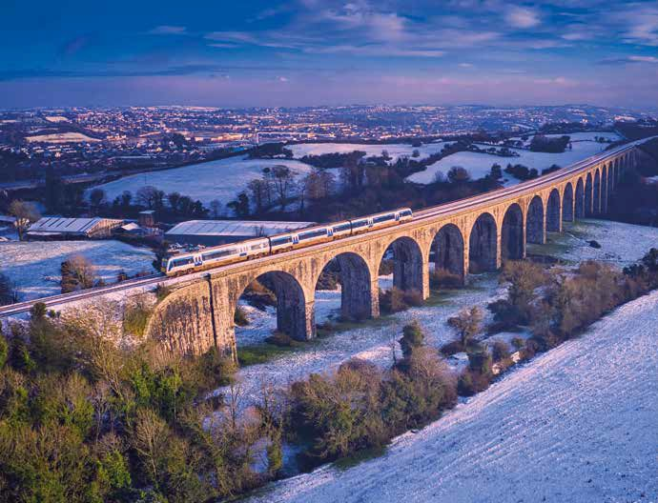
Downpatrick Portaferry

Belcoo
•

Lisnaskea
•
Teemore
•

Keady
•
•••

Newtownhamilton
•
•
•

Newry
•••

Rathfriland
•
•••

Newcastle
•••
•

Ardglass
•

Crossmaglen
•
Warrenpoint

•Kilkeel

20 Infrastructure and Projects Directorate Business Plan 2021/2022 Infrastructure and Projects Directorate Business Plan 2021/2022 21

Appendix E: Revenue Budgets 2021/22

The table below provides an overview of the revenue budgets for the Infrastructure and Projects Directorate for 2021/22 by Department and by Translink Group companies.

Appendix F: Capital Investment 2021/22

The projects listed below are among those that will be substantially advanced and/or completed during the financial year 2021/22.

 | Company (£’000)
Income | Ulsterbus | Metro | NIR | NITHC | Total
Estates | (318) | (352) | 0 | 0 | (670)
Systems and Performance | 0 | 0 | (5,860) | 0 | (5,860)
Total Income | (318) | (352) | (5,860) | 0 | (6,530)
Costs
Portfolio Management Office | 64 | 23 | 84 | 0 | 171
Estates | 49 | 27 | 66 | 547 | 689
Permanent Way | 0 | 0 | 6,875 | 0 | 6,875
Signalling | 0 | 0 | 4,491 | 0 | 4,491
Structures | 0 | 0 | 3,564 | 0 | 3,564
Property | 1,059 | 275 | 1,273 | 0 | 2,607
Network Assurance & Safety | 0 | 0 | 591 | 0 | 591
IM Rail Control | 0 | 0 | 1,145 | 0 | 1,145
IM Rail Ops Signalling | 0 | 0 | 2,984 | 0 | 2,984
NITHC Estates | 0 | 0 | 0 | 0 | 0
Systems and Performance | 0 | 0 | 427 | 0 | 427
Property Mechanical and Electrical | 834 | 184 | 922 | 0 | 1,940
Property Asset Management | 107 | 38 | 146 | 0 | 291
Project Delivery - Property | (030) | (05) | (054) | 0 | (089)
Project Delivery - Renewals | 0 | 0 | (028) | 0 | (028)
Project Delivery - Major Projects | 35 | 19 | 107 | 0 | 161
Director of Infrastructure and Projects | 112 | 34 | 304 | (016) | 434
Total Costs | 2,230 | 595 | 22,897 | 531 | 26,253
Net Costs | 1,912 | 243 | 17,037 | 531 | 19,723

Activity – 2021/22 | Primary Purpose |  | Start Date | Expected Completion Date
 | Safety | Capacity
Ongoing and Immediate Future
Platform Safety |   |  | Oct-20 | Dec-21
Rail Milling Programme |   |  | Oct-20 | Mar-23
Ballymoney to Coleraine Re-railing |   |  | Oct-21 | Jul-22
Lineside Fencing Programme 2019-2022 |   |  | Dec-19 | Mar-23
Whitehead UWC Upgrade to MSL |   |  | Oct-21 | Jul-22
Holywood Sea Defences |   |  | Mar-21 | Sep-21
UWC Safety Improvement Programme Phase 2a |   |  | Apr-17 | Sep-22
UWC Safety Improvement Programme Phase 2b |   |  | Nov-21 | Jul-23
UWC Renewals |   |  | Oct-21 | Nov-22
Bridge Refurbishment & Strengthening Programme Phase 2 |   |  | Mar-21 | Mar-22
Fortwilliam - Bleach Green Signalling Renewals |   |  | Mar-21 | Dec-21
MSL Isolation Switch Facility |   |  | Nov-20 | Sep-21
Invasive Species Treatment Bus &/ Rail |   |  | May-19 | Sept-22
NT3 Sidings at Coleraine |   |  | Jul-21 | Sep-21
Dark Arch Whiteabbey Track Renewal |   |  | Jul-21 | Feb-22
Cullybackey Level Crossings MCB Upgrade |   |  | Oct-21 | Dec-23
Closure of XL96, 97, 107 & 108 (Dunloy) |   |  | Jan-21 | Oct-21
Closure of XL122-126 (Ballymoney) |   |  | May-21 | Nov-21
Belfast Transport Hub – Enabling Works |  |   | Jan-20 | Jul-21
Yorkgate Station Redevelopment |  |   | Oct-21 | May-22
Northern Ireland Railway Operations Centre (NIROC) Phase 1 |   |  | Nov-19 | Nov-24
Trooperslane Park & Ride |  |   | Mar-21 | Feb-22
Platform LED Lighting Replacement |   |  | Nov-21 | Nov-22

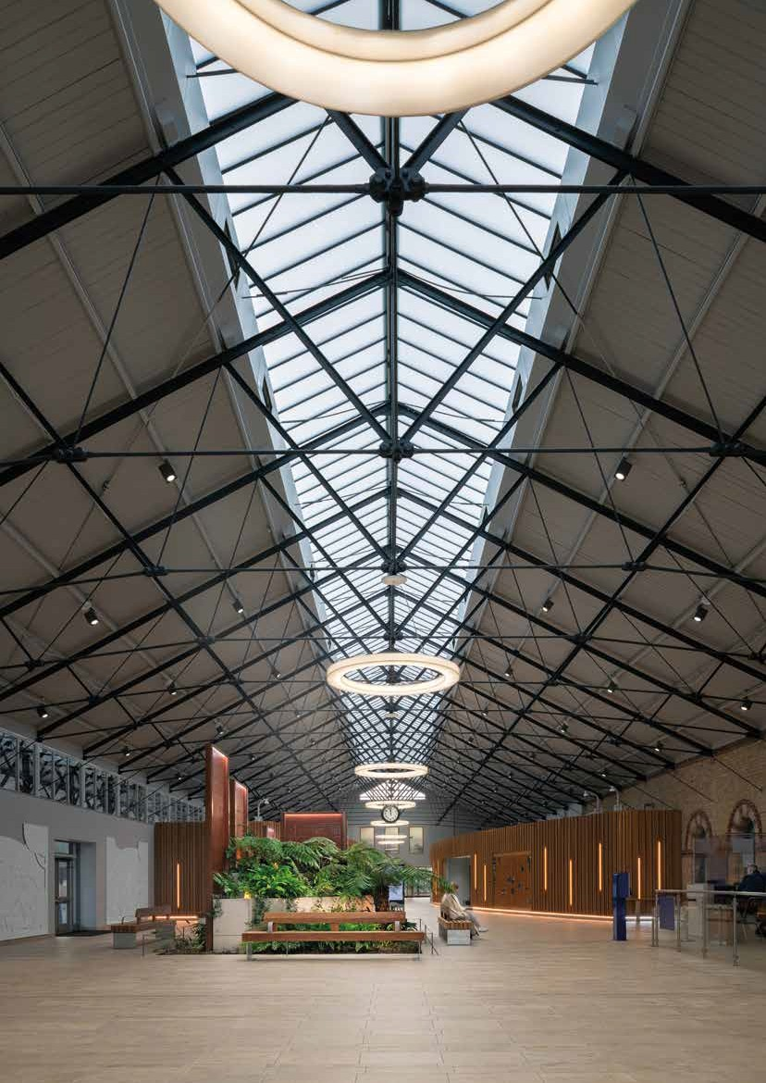

22 Infrastructure and Projects Directorate Business Plan 2021/2022 Infrastructure and Projects Directorate Business Plan 2021/2022 23

Appendix G: Group Structure

Translink Group – Company Structure

Ulsterbus Limited
Citybus Limited (Metro)
Northern Ireland Railways
NITHC
Department for Infrastructure

Translink Group - Management Structure
Chief Financial Officer
Corporate HR & Corporate Services Officer
Chief Business Change Officer

Board
Director of Infrastructure & Project Delivery

Director of Commercial Operations
Director of Service Operations

Group Chief Executive

This publication is available in a range of alternative formats, for example large print, braille or audio tape. Please call Translink Contact Centre 028 9066 6630.

Special thanks to all our customers and staff who kindly allowed us to use their photos in this publication.

