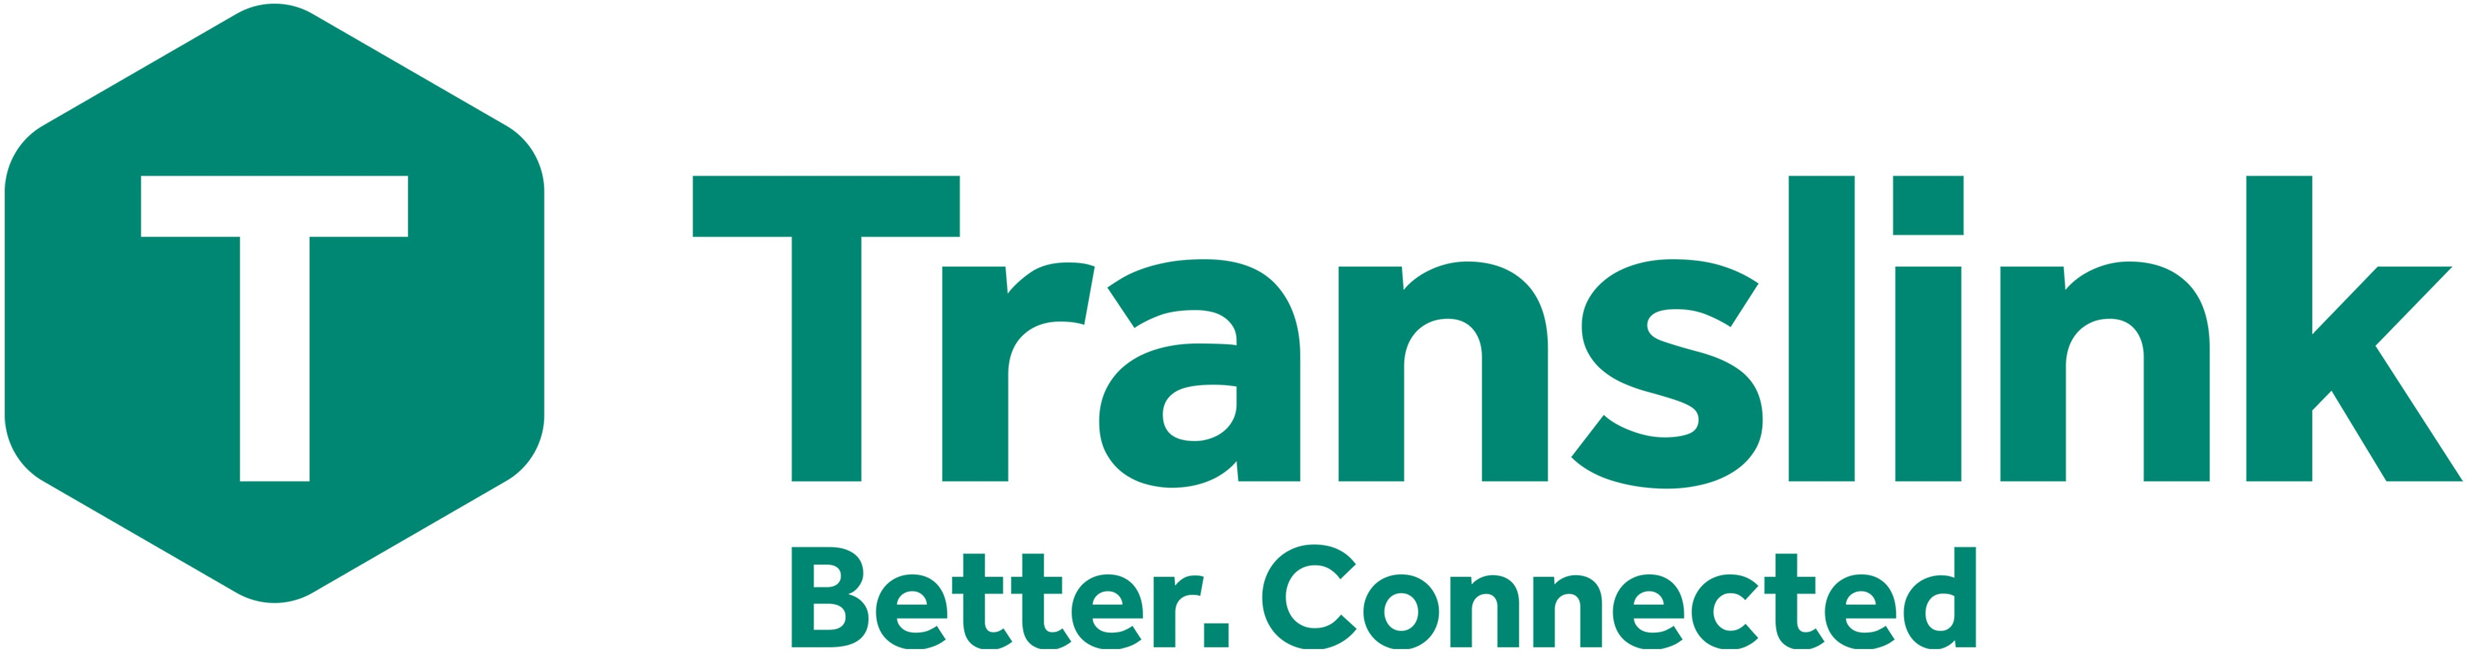
Subject Access Request Form

Details of person requesting the information

Title: Mr
Mrs
Miss Ms

Surname Forename

Business Name (if applicable)

Current Address

House Number & Street

Town County

Postcode Telephone Number

Email Address

Are you an employee or ex-employee of Translink?

Yes No

If yes, please supply your date of leaving Staff Number

If staff number unknown, please indicate which Department worked in:

Are you the data subject?

Yes
Question 5)
If you are the data subject please supply photocopied evidence of your identity to Translink. Translink reserves the right to request further proof of identity. (Go to

Please attach photocopies of one of the following,

Please tick below what evidence you have enclosed:

Birth Certificate Valid Driver’s Licence

Passport
Utility Bill
Other

(Go to Question 5)

No If you are acting on behalf of the data subject you MUST provide proof of authority and proof of data subject's identity.
(Please complete sections 3 and 4)

Details of the data subject

Title: Mr
Mrs
Miss Ms

Surname Forename

Current Address

House Number & Street

Town County

Postcode Telephone Number

Email Address

Continued overleaf

V1.2
July 2022

- Please describe your relationship with the data subject that leads you to make this request for information on their behalf. Please complete in box below and attach proof of authority and proof of data subject's identity:

- What information are you requesting from Translink about the data subject? Please assist us by providing specific details in the box below, by including dates, times, locations, departments etc:
DECLARATION:

I, (requestor’s name) certify that the information given in this data subject access request form to Translink is true. I understand that it is necessary for Translink to confirm my/the data subject’s identity and I understand that it may be necessary to obtain more detailed information in order to locate the correct information.

Signature Date

WARNING: A person who impersonates or attempts to impersonate another may be guilty of an offence.

Translink will reply and set the start date for the 1-month period in which to respond to the request once Translink is satisfied upon the matters above and that all sections have been completed and all appropriate documentation forwarded.

Checklist:
- Have you completed all of the appropriate sections and enclosed applicable documentation?
- Have you signed the form?
- Have you enclosed your proof of identity?
Completed forms should be returned to:

Legal and Governance office, Translink, 22 Great Victoria Street, Belfast, BT2 7LX or email: dpo@translink.co.uk

Office Use Only:

Date form received: Adequate ID received: Letter of authority received:
Signed: Date:

V1.2
July 2022

