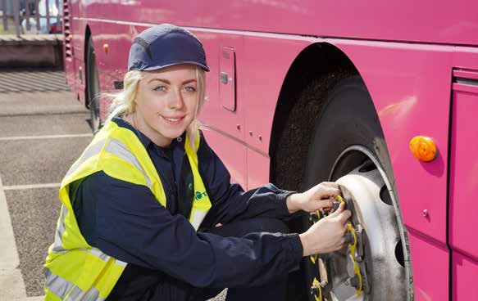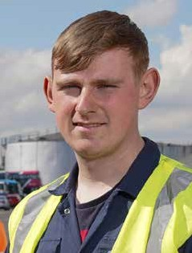

GATEWAY TO YOUR FUTURE
Engineering Apprenticeships with Translink 2022

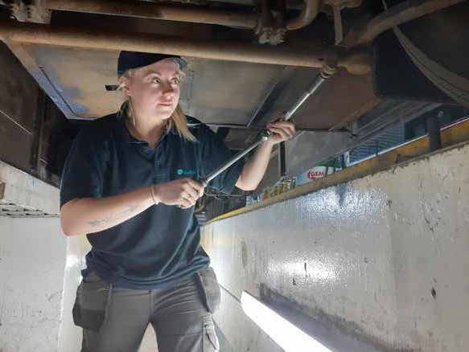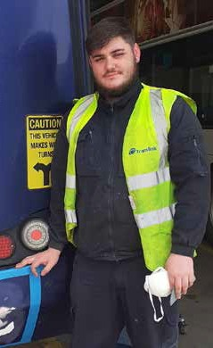

WELCOME
TO TRANSLINK
Foreword

Thank you for your interest in the Translink Apprenticeship Programme. This is an exciting time to join a dynamic and growing company with significant opportunity to fast track your career within one of Northern Ireland’s largest organisations.
Translink provides award-winning bus, coach and rail services and is recognised as an industry leader who has continued to deliver strong performance despite challenging economic times. At present, we have over 4100 employees and pre-covid were responsible for approximately 84 million customer journeys each year.
Translink’s commitment to zero emission public transport took a step forward with the recent launch of our zero emission bus fleet for Belfast Metro, and we’ve exciting plans for both Foyle Metro and Ulsterbus. In parallel we’ve been increasing the capacity on our rail network through the delivery of our lengthened six car trains.
This Translink Bus Engineering Apprenticeship Programme is an excellent opportunity to develop your skills and your career alongside a diverse and experienced team, who will mentor and encourage you along the way. If you like working in a team, are enthusiastic and conscientious then I would encourage you to apply. We will support Apprentices in their development, ensuring they reach their full potential to establish future careers in Engineering.
The future is exciting for Translink and we look forward to you playing your part on that journey.
May I take this opportunity to wish you all the best with your application.

David Barnett
General Manager Engineering

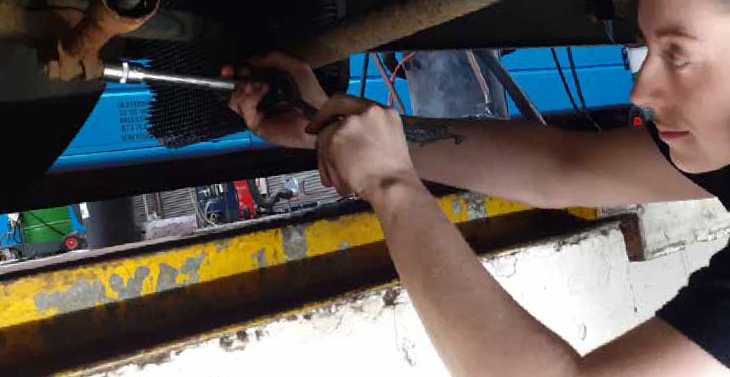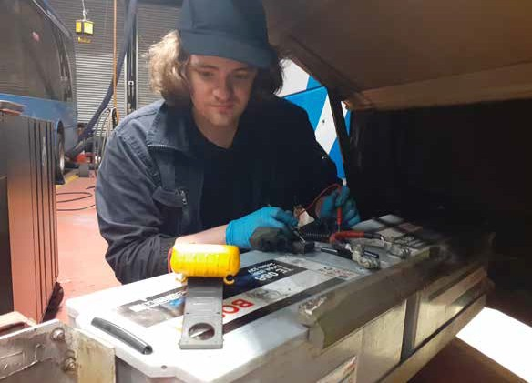WHO ARE TRANSLINK?

Translink is Northern Ireland’s main public transport provider. We are a public corporation which has a degree of commercial independence, yet are governed in policy terms by the Department for Infrastructure. We provide an essential public service to the people of
Northern Ireland which impacts on everyone, supporting economic growth, social inclusion and the welfare of the local communities we serve. This supports the growth and prosperity of Northern Ireland

The Engineering Division plays a major role in ensuring safe, reliable, and well-presented buses and trains are available for service when required. The teams operate from 26 workshops across the province and utilise the latest technology with a focus on continuous improvement.

We are an award-winning engineering department and have gained many accolades over the years including: The Institute of Road Transport Engineers, the Northern Ireland
Your first choice for travel, today, for tomorrow.
TRANSLINK VISION
‘‘
Apprenticeship Awards and IRTEC Skills Challenge Award where we get the opportunity to compete against other UK bus operators.

As an Engineering Apprentice in Translink we will give you the opportunity to learn and develop your skills and knowledge. In fact, many of our engineering management positions are currently occupied by previous Apprentices which highlights the high standard of recruitment and training received.

If learning about the latest technology on vehicles is what you are interested in, now is a great time to join the engineering team at Translink. We have a fleet of Glider vehicles
which embrace the latest hybrid technology. We also recently launched a fleet of hydrogen powered vehicles which are the first of their kind on the Island of Ireland. Following these was a delivery of Battery Electric Vehicles which are being used in urban settings. This will move us closer to our goal of becoming carbon neutral by 2040.

WHY YOU SHOULD APPLY FOR OUR APPRENTICESHIP SCHEME

Practical on-the-job training
Gain experience and a professionally
accredited qualification at the same time at no monetary cost to you!
Competitive salary

Career progression and personal development
Minimum of 25 days annual leave + set public holidays
(pro rata)
Free travel (subject to eligibility) on Translink services

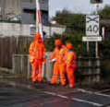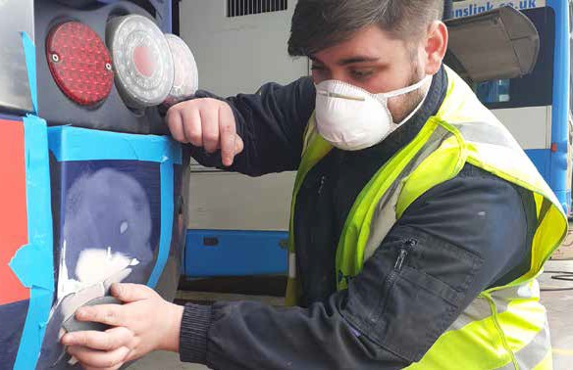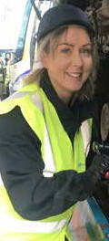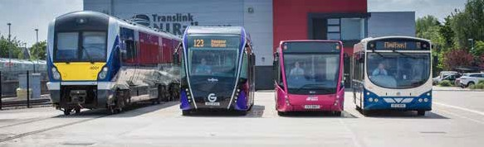Attractive NILGOSC Pension Scheme
TRANSLINK
MISSION AND VALUES
Translink’s mission is to lead the transformation of transport in
Northern Ireland: we will create the advanced public transport services and integrated networks which connect people and communities, enhance
the economy and improve health and the environment.

Translink is passionate about providing excellent public transport and this is endorsed by their guiding Values;

Safety, People, Innovation, Responsibility, Integrity and Teamwork This is the Translink ‘SPIRIT’.
Opportunity to join Employee Benefits Scheme offering you discounts
from local retailers and service providers including restaurants,
gym membership, hotels, cinemas etc.

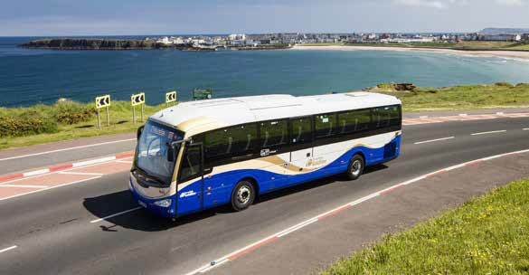What is an Apprenticeship?
An Apprenticeship is a real job offering hands on experience, comprehensive training and a technical qualification all whilst earning a salary. The Translink Apprenticeship Programme will give you the skills, knowledge and behaviours to become an Engineer.

For these opportunities in Bus Engineering anyone aged 16 years or over can apply. All our apprentices are fully employed by Translink from the first day of their apprenticeship with a contract of employment, paid holidays and many other
competitive benefits. As an apprentice you will be working with experienced staff and learning from colleagues across all levels of the business.

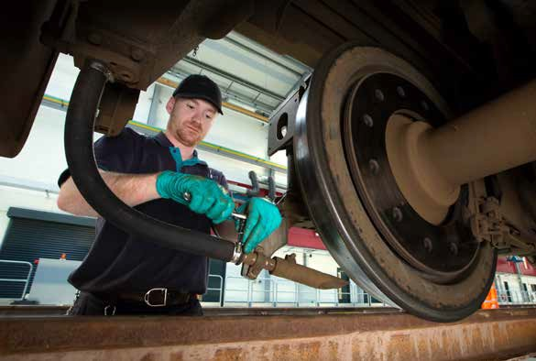
2022
Translink, operating as Ulsterbus, Metro, Northern Ireland Railways and NITHCo, operates 1355 buses, coaches and Gliders, alongside 45 trains, providing the Northern Ireland public with comprehensive stage carriage, express and school transport services. This extensive provision requires modern and varied engineering facilities which are located throughout the province.

In order to maintain and develop the highest standards of engineering, we have identified opportunities for structured 4-year Apprenticeships which will commence in September 2022.
Your first choice for travel, today, for tomorrow.
TRANSLINK VISION
‘‘

TRANSLINK ENGINEERING APPRENTICESHIPS
Completing an apprenticeship with Translink will equip you with skills for life as well as enabling you to secure permanent employment and gain a professional level 3 NVQ qualification.

This Apprenticeship involves a combination of working and learning on site at a Translink workshop for 4 days a week whilst attending college on one day to
complete a formal NVQ Qualification. You will benefit from the knowledge of skilled professionals who will support and mentor you as you learn.

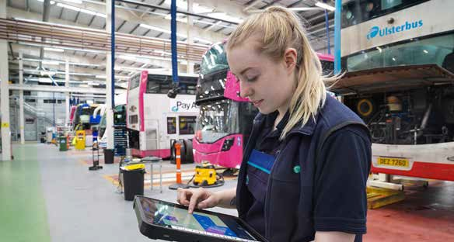ENGINEERING APPRENTICESHIP ROUTES

We currently have opportunities available for Bus Engineering Apprenticeships across the following trades -

Technical Trades
A Technical Trades Apprenticeship is four years in duration. With today’s modern vehicle it is recognised that training in a combination of mechanical and electrical systems is essential. To ensure that adequate training on both systems is provided we take the apprentice through four NVQs i.e. Mechanical and Electrical at level
2, Mechanical and Electrical at level 3. This approach is designed to equip our apprentices with the knowhow and skills required for the future and to instil confidence in the Apprentice ensuring they are competent in both trades. Apprentices attend college one day per week with the remaining four days spent at a Translink workshop where the college training is put into practice.

Body Trades
A Body Trades Apprenticeship is four years in duration and combines the skills of three core trades i.e. Sheet Metal, Body Building and Painting. Body Trades Apprentices will attend a further education college on a day release basis for three years to undertake a Coach and Bus Body qualification. Upon completion,
Apprentices will be qualified to NVQ Level 3 including a Technical Certificate. When not at college Apprentices work in a Translink workshop.

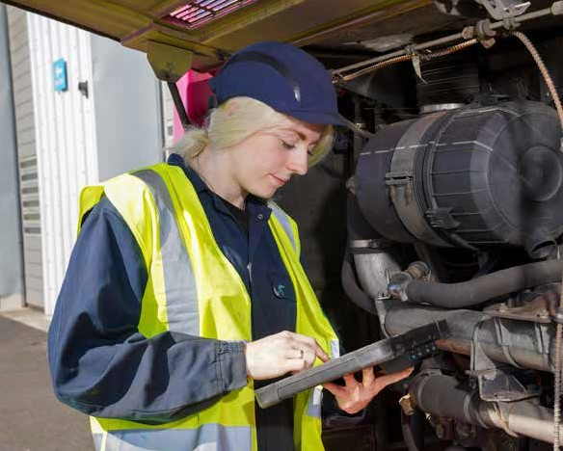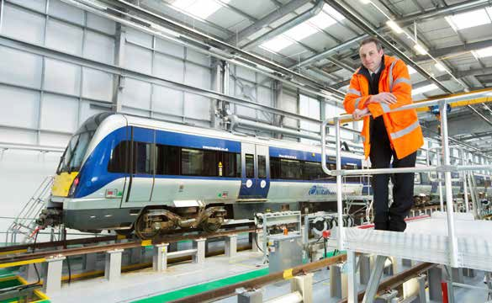BENEFITS

- A competitive salary
- Attractive NILGOSC pension including employer contribution
- Minimum of 25 days annual leave plus statutory holidays
- Diversity and inclusion networks and initiatives
- Monthly wellbeing initiatives
- Employee benefits scheme offering many discounts
- Access to Cycle to Work scheme enabling you to purchase a new bike and safety equipment up to the value of £2,000 for up to 30% less than the original cost through salary sacrifice
- Confidential counselling service
- Opportunity to get involved in charity fundraising and social value initiatives
- Volunteering opportunities

LOCATIONS
Locations of Engineering Apprenticeship Opportunities

The Bus Engineering Apprenticeships will be based at depots in Belfast (multiple locations), Craigavon, Larne, Magherafelt and Omagh

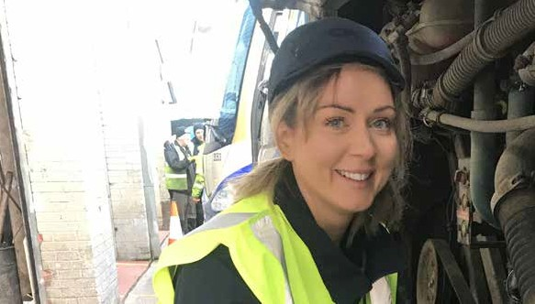Are there alternative routes into the job?
Ciara McIlroy
YEAR 2 APPRENTICE
MEET AN APPRENTICE
You can go to college to study Heavy Vehicle qualifications then apply as a qualified Fitter when jobs become available and are advertised on the Translink website.

What does a typical day entail?
Doing 4 week safety checks, getting buses ready for PSV and any unscheduled repairs on a bus.

What are the best and most challenging aspects of the job?
I find the job very interesting, the best part is getting involved in engine services and changing brake discs/pads. The more you do them the easier it gets. For me, the most challenging part of the job has been building up my strength as the parts are heavier than a light vehicle but I am getting stronger and all I have to do is ask for help to lift something I feel is too heavy.

Give a brief outline of your career to date
After completing my A-levels at school, I went to Belfast to study Business (HNC). Although I found Business interesting, I realised that I didn’t like the idea of sitting in an office 5 days a week. Therefore, I began looking for another career path which led to an NVQ in beauty, as it was a hands-on job. Once qualified, I moved to Australia, it was there that I realised I was more suited to a career working outdoors. Railway life appealed to me so I completed some courses to pursue a career in the Australian railways. I qualified as a level 2.2 Hand Signaler before progressing to a level 3.1 Track Force Coordinator (safety). Following this, I was offered a job to work in the Engineering Department, maintaining track in the north-west of Melbourne. This
enabled me to work both in the office and out on the track as a Track Support Officer. After a year in Australia I decided to come home. It was then that the opportunity to pursue a career in Engineering with Translink arose.

Is this what you always wanted to do?
I didn’t know what I wanted to do but I knew I wanted an active job. Once I commenced training as a Heavy Vehicle Technician I knew I was in the right place.

Were there any particular qualifications or experience needed?
To get into the Translink apprenticeship programme I needed 5 GCSEs to successfully pass an aptitude test and to undergo an interview. I believe that my farming background and experience working around machinery on the railways in Australia helped me at my interview.

Why is what you do important?
Without the engineering department the buses and trains would not be maintained leaving some people without public transport to get them from A-B.

What advice would you give to anyone looking to follow a similar career path? If this is a career you really want to get into, then don’t give up. There are lots of courses provided by colleges which can help upskill you for an engineering role. Don’t let others opinions stop you from pursuing your chosen career.

What’s the one piece of advice you would give yourself on your first day?
Don’t be afraid to get stuck in and ask as many questions as you need to.

What is the key to a successful job search?
If you are interested in joining Translink, follow them on all aspects of social media, turn on all job alerts and keep up to date with new roles advertised on www.translink.co.uk/workwithus
‘‘

Don’t be afraid to get stuck in and ask as many questions as you need to.

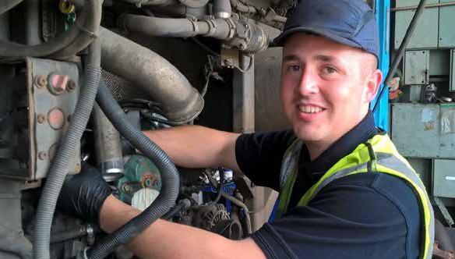...an opportunity to learn and gain qualifications.
Kevin Doherty
YEAR 4 APPRENTICE
MEET AN APPRENTICE

What does a typical day entail?
A typical day as an apprentice can be varied as you get a wide range of experience working in different areas and as part of different teams. This can include carrying out scheduled safety inspections, preparing buses for PSV or diagnosing and repairing buses that have broken down. You get a wide and varied experience of all aspects of maintaining the fleet whilst working alongside an experienced member of the team.

‘‘

Give a brief outline of your career to date
I studied Advertising & Marketing at the University of Ulster where I graduated with a 1st class honours degree. I then worked within the marketing industry as a Marketing Executive for a number of different companies. Unhappy working in an office based role within the Marketing Industry I decided to seek a career change. I always had
an interest in all things engineering and mechanical so I sought a more hands-on career. I began looking for courses and opportunities to enable me to retrain when I came across the Translink Apprenticeship Programme. I thought this would be a great opportunity as it offered on the job experience, qualifications whilst earning a wage. I am currently a 3rd year apprentice based in Coleraine.

Is this what you always wanted to do?
Having grown up with a keen interest in all things engineering and with my father being a HGV mechanic I always imagined myself in this line of work. However (for some unknown reason) I ended up going to university to study marketing!!

Where there any particular essential qualifications or experiences needed? For the apprenticeship programme a minimum of 5 GCSEs at grade C or above or equivalent including Maths and English was required.

Are there alternative routes into the job?
There are often opportunities for already qualified engineers to enter this position.

What are the best and most challenging aspects of the job?
One of the best aspects of the job would be the fact no two days are the same, this keeps the job challenging and interesting. There is also great job satisfaction
when you carry out repairs and the bus is able to get back on the road; you see that your hard work has paid off. The most challenging aspect can be the diagnosing
of complex faults- due to rapid technological advances faults are becoming more complex and often require much more diagnostic techniques in order to track down the issue.

Why is what you do important?
Translink offer/provide vital services to many members of the community and for these services to run as efficiently as possible it is important that the buses are kept to a high standard and are safe to be on the road. The role of an engineer is important as it involves maintaining a safe and reliable fleet of vehicles for customers to use.

What advice would you give anyone looking to follow a similar career path?
If you know that this is what you want to do, then go for it. An apprenticeship is a great way to get into the industry. It gives you an opportunity to learn and gain
qualifications whilst getting the all-important on the job experience and gives you the chance to earn while you learn.

What’s the one piece of advice you would give yourself on your first day? Don’t get overwhelmed - it’s a lot to take in but with great support you will settle in and start learning very quickly.

And finally, what’s the key to any successful job search?
Having confidence in yourself, your ability and having the determination and motivation to keep going, even if unsuccessful at first.

APPRENTICE PROFILE
GATEWAY TO YOUR FUTURE
Engineering Apprenticeships with Translink 2022

Minimum Criteria
- Aged 16 years old or over on or before the 1st August 2022
- Minimum of 5 GCSE’s at grade C or above (or equivalent qualification) including Maths and English, or be expecting to receive these by August 2022
- Experience of using Microsoft Office packages
- Able to demonstrate examples of a practical hands-on approach
- Team player with a positive attitude
- Committed, self-motivated and willing to respond to the needs of the Apprenticeship scheme
- Excellent communication skills
- Understand how to provide an excellent customer experience

Recruitment Process
- Online application form - www.translink.co.uk/workwithus
- Aptitude testing
- Interview
- Pre-employment references, medical and qualification checks (if successful)

EQUAL OPPORTUNITY POLICY
Translink values its employees and is committed to building a diverse and inclusive workplace that attracts, retains and develops the best talent. We are an equal opportunities employer, in this instance applications from women would be particularly welcome.

